

*Three - phase Multifunction Power Meter*

*PAC5000 Series*

User Guide V1.0

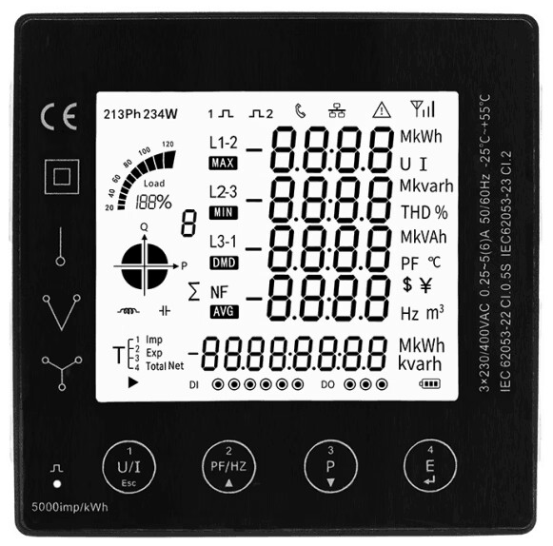

**Wenzhou Taiye Electric Co., Ltd.**

**Safety Information**

**Important Information**

Read these instructions carefully and look at the equipment to become familiar with the device before trying to install, operate, service or maintain it. The following special messages may appear throughout this bulletin or on the equipment to warn of potential hazards or to call attention to information that clarifies or simplifies a procedure.



The addition of either symbol to a “Danger” or “Warning” safety label indicates that an electrical hazard exists which will result in personal injury if the instructions are not followed.



This is the safety alert symbol. It is used to alert you to potential personal injury hazards. Obey all safety messages that follow this symbol to avoid possible injury or death.

|  |
| --- |
| **DANGER** |
| **DANGER** indicates an imminently hazardous situation which,if not avoided, will result in death or serious injury. |

|  |
| --- |
| **WARNING** |
| **WARNING** indicates a potentially hazardous situation which, if not avoided, can result in death or serious injury. |

|  |
| --- |
| **CAUTION** |
| **CAUTION** indicates a potentially hazardous situation which, if not avoided, can result in minor or moderate injury. |

|  |
| --- |
| ***NOTICE*** |
| **NOTICE** is used to address practices not related to physical injury. The safety alert symbol shall not be used with this signal word. |

**Please Note**

Electrical equipment should be installed, operated,serviced, and maintained only by qualified personnel. No responsibility is asumed by Nova for any consequences arising out of the use of this material.

A qualified person is one who has skills and knowledge related to the construction, installation, and operation of electrical equipment and has received safety training to recongnize and avoid the hazards involved.

**Table of Contents**

**Chapter 1. Overview** - 1 -

1.1. Introduction - 1 -

1.2. Characteristics - 1 -

1.3. Parameters - 2 -

Chapter 2．Technical parameters specification - 3 -

2.1. Specification - 3 -

2.2. Installation dimensions - 6 -

2.3. Wiring Diagrams - 6 -

**Chapter 3．General function description** - 9 -

3.1. Display icon description - 9 -

3.1.1. Bar graph for power - 9 -

3.1.2. Digital I/O indicating icon - 10 -

3.2. Multi-tariffs function - 10 -

3.3. Demand calculation method - 10 -

3.3.1. Fixed block interval - 10 -

3.3.2. Sliding block interval - 11 -

3.4. System current direction correction function - 11 -

3.5. Description of energy display format - 12 -

**Chapter 4．Operation** - 12 -

4.1. Power meter startup instructions - 12 -

4.2. LCD display area description - 13 -

4.3. Button definition description - 14 -

4.4. Description of display screen - 14 -

4.4.1. Main display screen - 14 -

4.4.2. Auxiliary display screen - 17 -

4.5. Setting-up - 19 -

4.5.1. Set communication class parameters - 22 -

4.5.2. Set CT class parameters - 24 -

4.5.3. Set PT class parameters - 25 -

4.5.4. Set system class parameters - 27 -

4.5.5. Set pulse output class parameters - 30 -

4.5.6. Set demand class parameters - 31 -

4.5.7. Set time class parameters - 33 -

4.5.8. Reset - 36 -

4.5.9. Set digital input (DI) class parameters - 37 -

4.5.10. Set digital output (DO) class parameters - 38 -

4.5.11. Set alarm (AL) class parameters - 40 -

4.5.12. View SOE log information - 46 -

**Chapter 5. Digital input (DI) interface** - 47 -

5.1. Function declaration - 47 -

5.2. Description of filter function for input detection - 47 -

**Chapter 6. Digital output (DO) interface** - 48 -

**Chapter 7. Alarm** - 49 -

7.1. Alarm parameter description - 49 -

7.2. Alarm parameter setting process - 50 -

7.3. Rules for alarm monitoring - 51 -

7.4. Alarm action process - 52 -

7.5. View the alarm event record - 52 -

**Chapter 8．Modbus register address table** - 53 -

Appendix - 54 -

Appendix A – LCD character definition table - 54 -

Appendix B – Power meter functional comparison table - 54 -

Appendix C – Introduction to the main display screen - 55 -

Appendix D – Introduction to auxiliary information display screen - 59 -

**Chapter 1. Overview**

## 1.1. Introduction

PAC5000 series products are the multi-function power analysis instrument for collection and analysis of electric parameters, used not only in the electricity transmission and power distribution system, but also in the power consumption measurement and analysis in high voltage intelligent power grid. This series of products that can support a variety of electric parameter measurement analysis, such as voltage, current, the four quadrant power parameters, power factor, total harmonic distortion, individual harmonic distortion, unbalance factor, crest factor, etc. This series of products also provide a variety of electrical energy parameters measurement, such as two-way active energy, reactive energy, four-quadrant energy, monthly and daily energy consumption statistics.

PAC5000 series products can support in the 1P2W, 2P3W, 3P3W and 3P4W grid environment analysis of electric power parameter measurement, and at the same time providing multi-channel digital input/output interface, and SOE function, is suitable for real time power monitoring and control system, the energy consumption management system, industrial monitoring site using a variety of applications such as environment, has the multi-function, high stability and long life characteristics.

PAC5000 series products can support external voltage transformer (PT) and current transformer (CT) access, the maximum current up to 9999A, the maximum voltage up to 600kV. This series of products with RS485 communication interface, baud rate maximum support 38400bps, supporting Modbus, DLT645 communication protocols. It can easily realize the function of remote data read, and adopt the design of large-screen LCD and touch-sensitive key, which can easily carry out the local view and set operation of various parameters. The product has the function of password protection, which ensures the data security of the product.

## 1.2. Characteristics

* Multi-function parameter measurement, providing voltage, current, active power, reactive power, apparent power, power factor, phase Angle, etc.
* Provides a variety of analytical parameters, such as total harmonic distortion (THD) and Individual harmonic distortion (IHD) of voltage/current, voltage/current unbalance factor, voltage crest factor, current K factor, etc. The Sub-harmonic component is maximum supported to the 63rd.
* Provide a variety of statistical data and local storage functions, such as two-way power, four-quadrant power, demand, maximum/minimum value and other statistical data. Provide monthly electricity consumption statistics for the last 12 months and daily electricity consumption statistics for the last 31 days.
* External current transformers of output types such as 5A/100mV/100mA are supported, and direct access of Rogowski coil is also supported. With the current transformer reverse connection correction function.
* Support external voltage transformer access, input voltage minimum support 30V.
* Embedded installation, product panel size is 96*96mm.
* Plug and pull type connection mode, convenient construction connection.
* Liquid crystal display with backlit, backlight lighting time adjustable.
* LCD refresh time is 1 second, support manual or automatic scroll display (configurable).
* Support multi - channel digital input and output interface.
* Two pulse optocoupler output interfaces are pulse 1 and pulse 2 respectively. The output parameter can be set for pulse 1, while the fixed pulse 2 represents the total active energy of the secondary side, which cannot be set.
* Support RS485 communication function, baud rate up to 38400bps, support Modbus RTU, MBus protocol.

1.3. Parameters

|  |  |
| --- | --- |
| **1. The Unit can measure and display** | |
| **Instantaneous RMS Values** | |
| Current | Per phase, neutral |
| Voltage | L-L, L-N |
| Frequency | 45 to 65Hz |
| Active power | Total and per phase |
| Reactive power | Total and per phase |
| Apparent power | Total and per phase |
| Power factor | Total and per phase |
| Phase sequence | Voltage phase sequence, Current phase sequence |
| **Energy Values (include: import, export, import + export)** | |
| Active energy | 0 to 1.0*1014 Wh |
| Reactive energy | 0 to 1.0*1014 varh |
| Multi-Tariff active energy (T1 - T4) | 0 to 1.0*1014 Wh |
| **Maximum Demand Values** | |
| Max.Demand of current | Per phase, neutral |
| Max.Demand of active power | Total |
| Max.Demand of reactive power | Total |
| Max.Demand of apparent power | Total |
| **Harmonic Distortion Values** | |
| Total harmonic distortion (THD) | Current and voltage (L-L and L-N) |
| Individual harmonic distortion (IHD) | Current and voltage (L-L and L-N), 2~63rd |
| **Maximum and Minimum Values** | |
| Max./Min.Value of voltage | L-L, L-N |
| Max./Min.Value of current | Per phase, neutral |
| Max./Min.Value of active power | Total and per phase |
| Max./Min.Value of reactive power | Total and per phase |
| Max./Min.Value of apparent power | Total and per phase |
| **2. The Unit can measure and communication read** | |
| **Power Quality Values** | |
| Voltage unbalance factor | Negative-sequence, Zero-sequence |
| Current unbalance factor | Negative-sequence, Zero-sequence |
| Voltage crest factor | Per phase |
| Current K factor | Per phase |
| Nature of load | System total load, Per phase load |
| Displacement power factor | Total and per phase |
| **Maximum Demand Values** | |
| Max.Demand of active power | Import active power, Export active power |
| The occur time of max. demand | Voltage, Current, Active power, Reactive power, Apparent power |
| **Maximum and Minimum Values** | |
| Max./Min.Value of current | Total current |
| Max./Min.Value of power factor | Total and per phase |
| Voltage THD | L-L, L-N |
| Current THD | Per phase |
| The occur Time max./min.Value | Voltage, Current, Active power, Reactive power, Apparent power,  Power factor, Voltage/Current THD |
| **Energy Values** | |
| Apparent Energy (total) | 0 to 1.0*1014 VAh |
| Per phase energy | Active energy and reactive energy, include: import, export, import+export  Range: 0 to 1.0*1014 Wh/varh |
| Net energy | Active energy and reactive energy. (net = import - export)  Range: 0 to 1.0*1014 Wh/varh |
| Multi-Tariff active energy (T1 - T4) | Per phase active energy and reactive energy, include: import, export, import+export  Range: 0 to 1.0*1014 Wh/varh |
| Four quadrant reactive energy | 0 to 1.0*1014 varh |
| Monthly electricity consumption for the last 12 months | Active energy and reactive energy, include: import, export, import+export  Range: 0 to 1.0*1014 Wh/varh |
| Daily energy consumption for the last 31 days | Active energy, include: import, export, import+export  Range: 0 to 1.0*1014 Wh |
| **3. The Unit can settable** | |
| Communication class | Modbus address, baud rate, parity bit, stop bit |
| Current transformer (CT) class | CT1 (Primary), range from 1 to 9999  CT2 (Secondary), range is 1 or 5 |
| Voltage transformer (PT) class | PT1 (Primary), range from 30 to 600000  PT2 (Secondary), range is 30 to 600 |
| Power system type | 1P2W, 2P3W, 3P3P, 3P4W |
| System configuration class | Current direction correction, User password (HMI) |
| Demand class | Demand interval period, Slide time, Demand calculation method |
| Pulse output class | Pulse output type, Pulse output width, Pulse output rate |
| Time class | Automatic scroll display time, Backlit time, System time (RTC), Tariff time |
| Reset | Energy, Demand, Max./Min.Value, DI count, SOE info |
| Digital input (DI) class | DI filter time, DI count |
| Digital output (DO) class | Output mode, Pulse width time of output, Manual control |
| Alarm (AL) class | Alarm monitoring object, Delay time of alarm action, Alarm threshold value,  Alarm status |

# Chapter 2．Technical parameters specification

## 2.1. Specification

|  |  |  |
| --- | --- | --- |
| **Electrical Characteristics** | | |
| Type of measurement | | RMS including harmonics on AC system  128 samples per cycle |
| Measurement accuracy | Voltage, Current | Class 0.2, according IEC 61557-12 |
| Active power | Class 0.5, according IEC 61557-12 |
| Reactive power | Class 2, according IEC 61557-12 |
| Apparent power | Class 0.5, according IEC 61557-12 |
| Active energy | Class 0.5S, according IEC 62053-22  Class 0.5, according IEC 61557-12 |
| Reactive energy | Class 2, according IEC 62053-23  Class 2, according IEC 61557-12 |
| Power factor | Class 0.5, according IEC 61557-12 |
| Frequency | Class 0.05, according IEC 61557-12 |
| Harmonic distortion | Class 2, according IEC 61557-12 |
| Data update rate | | 1 second. Optional 100 ms |
| Input-Voltage | Rate voltage  (Un) | 230 Vac (L-N) / 400 Vac (L-L) |
| Measured range  (Direct connection) | 30 to 350 Vac (L-N), 30 to 660 Vac (L-L) |
| PT primary | 30 to 600000 |
| Impedance | 1MΩ |
| Frequency range | 45 to 65 Hz |
| Overload capacity | 2*Un for 1 second |
| Input-Current | CT2 (Secondary) | 1A or 5A  Optional: 100mA, 100mV |
| CT1 (Primary) | 1 to 9999 A |
| Measured range | 0.003 to 6 A, basic current (Ib) is 5A |
| Impedance | <0.01 ohm |
| Overload capacity | 120A for 0.5 second |
| Burden | <0.06VA at 6A |
| Auxiliary power supply | Operating range | 80 ~ 300 Vac / 100 ~ 420 Vdc |
| Frequency | 45 ~ 65 Hz |
| Power consumption | < 4VA/0.5W |
| Digital input  (DI) | Number | 4 |
| Type | Support dry contact input (built-in power supply: 20 ~ 24VDC) |
| Input Resistance | 10kΩ |
| Maximum frequency | 250Hz |
| Response time | 2 milliseconds |
| Isolation | 2.5 kVrms |
| Digital output  (DO) | Number/Type | 2 - electromagnetic relay |
| Output frequency | 10Hz maximum |
| Switching current | 250 Vac at 3.0 Amps, 100k cycles |
| Isolation | 2.5 kVrms |
| Pulse output | Interface type | Open collector optocoupler |
| Pulse constant | Per pulse equal 0.001/0.01/0.1/1/10/100/1000 kWh/kvarh (Configurable) |
| Pulse width | 60/100/200 milliseconds (Configurable), default is 100milliseconds |
| Pulse output type | Import/export/total active energy,  Import/export/total reactive energy (Configurable) |
| Class | Class A, according IEC 62053-31 |
| Input voltage | 5 ~ 27 Vdc |
| Pulse indicator light on the panel | | Pulse constant is 5000imp/kWh, Represents the total active energy of the secondary side |
| Real-time clock accuracy | | 1.0 s/d |
| **Mechanical Characteristics** | | |
| IP Degree of Protection (IEC 60529) | | Designed to IP51 front display, IP30 meter body |
| Dimensions (W X H X D) | | 96 x 96 x 70 mm (depth of meter from housing mounting flange)  96 x 96 x 14 mm (protrusion of meter from housing mounting flange) |
| Weight | | PAC5000: 350g. PAC5010: 360g. PAC5100: 390g. PAC5110: 400g. |
| Mounting Position | | Vertical |
| Panel thickness | | 1 ~ 5 mm |
| Material of meter case | | UL 94 V-0 |
| **Environmental Characteristics** | | |
| Operating Temperature | | -25 to +70℃ |
| Storage Temperature | | -40 to +80℃ |
| Humidity | | < 90%, non-condensing |
| Pollution Degree | | 2 |
| Altitude | | Up to 2000m |
| Vibration | | 10 Hz to 150Hz, IEC 60068-2-6 |
| **Electromagnetic Characteristics** | | |
| Electrostatic Discharge | | Level 4, according IEC 61000-4-2(1) |
| Immunity to Radiated Fields | | Level 3, according IEC 61000-4-3(1) |
| Immunity to Electrical Fast Transients | | Level 4, according IEC 61000-4-4(1) |
| Immunity to Surges | | Level 4, according IEC 61000-4-5(1) |
| Immunity to Conducted Disturbances | | Level 3, according IEC 61000-4-6(1) |
| Immunity to Magnetic Fields | | IEC 61000-4-8(1) |
| Immunity to Voltage Dips | | IEC 61000-4-11(1) |
| Radiated Emissions | | Class B, according EN55011 |
| Conducted Emissions | | Class B, according EN55011 |
| Harmonics | | IEC 61000-3-2(1) |
| (1): The experimental test is carried out according to the grade requirements of industrial grade products in IEC61326-1 | | |
| **Safety** | | |
| Measurement Category | | CAT III, according IEC 61010-1 |
| Current Input | | Require external Current Transformenr for Insulation |
| Overvoltage Category | | CAT III, according IEC 61010-1 |
| Insulation | | AC Voltage Test: 4kV for 1 minute |
| Impulse Voltage Test: 6kV - 1.2/50µS waveform |
| Protective Class | | II, according IEC61010-1 |
| **Communications** | | |
| Interfaces standard and protocols | | 2-wire RS485, Modbus RTU  Optional: MBus |
| Buad rate | | 1200 to 38400 bps, default is 9600 bps |
| Parity bit | | None, Even, Odd, default is None |
| Stop bit | | 1 or 2, default is 1 |
| Response time | | <100ms |
| Transmission mode | | half-duplex |
| Transmission distance | | Up to 1000m |
| Max. Bus loading | | 64 pcs |
| Firmware Update | | Support communication port to update firmware |

## 2.2. Installation dimensions

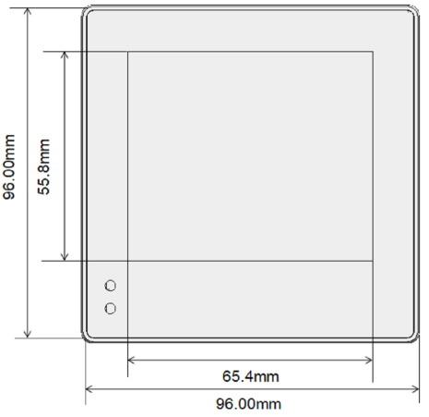 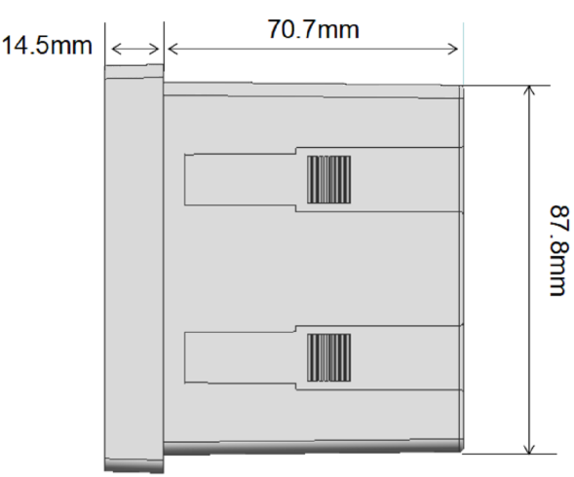

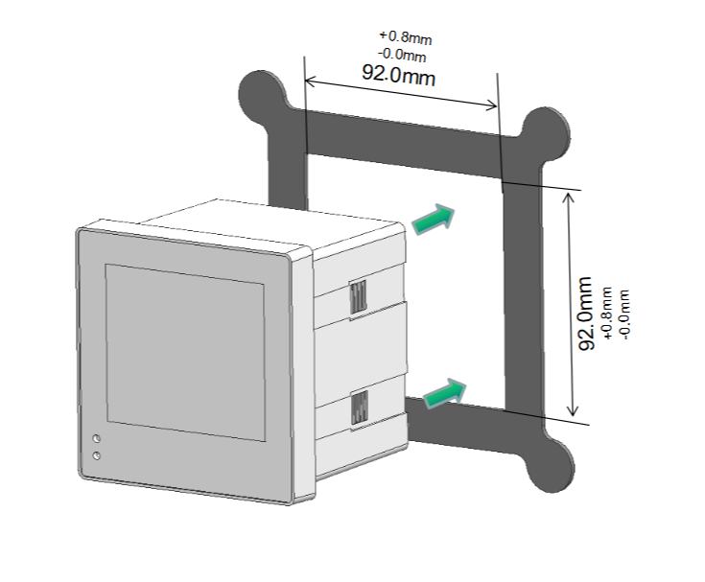 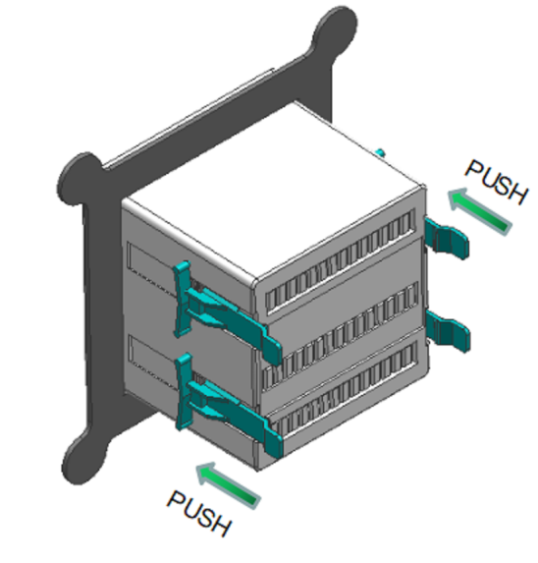

## 2.3. Wiring Diagrams

|  |  |  |  |
| --- | --- | --- | --- |
| **Measurement input wiring** | | | |
| 3P4W（3CT） | | 3P4W（3PT+3CT） | |
|  | |  | |
| 3P3W（2CT） | | 3P3W（2PT+2CT） | |
|  | |  | |
| 3P3W（3CT） | | 2P3W（L+L+N, 2CT） | |
|  | |  | |
| 1P2W（L+N，1CT） | | 1P2W（L+L，1CT） | |
|  | |  | |
| 1P2W（L+N，3CT） | |  | |
|  | |
| **Auxiliary power wiring** | | | |
| AC Power | | | DC Power |
|  | | |  |
| **Communication terminal wiring** | | | |
| Single meter wiring | | Multiple meters wiring | |
|  | |  | |
| **Pulse output terminal wiring** | | | |
|  | | | |
| **Digital inout and ouput terminal wiring** | | | |
|  | | | |
| : 500 mA fast fuse. | | | |
| : Fast fuse.  In use, the user needs to select the fast fuse according to the load specification parameters. | | | |
| **Terminal specification parameters** | | | |
| Voltage measurement input terminal | Wire size: 0.82 ~ 3.31 mm2 (18 ~ 12 AWG)  Torque: 0.5 ~ 0.6 N.m | | |
| Current measurement input terminal | Wire size: 1.318 ~ 3.31 mm2 (16 ~ 12 AWG)  Torque: 0.5 ~ 0.6 N.m | | |
| Auxiliary power terminal | Wire size: 0.82 ~ 3.31 mm2 (18 ~ 12 AWG)  Torque: 0.5 ~ 0.6 N.m | | |
| Communication terminal | Wire size: 0.82 ~ 3.31 mm2 (18 ~ 12 AWG)  Torque: 0.5 ~ 0.6 N.m | | |
| Pulse output terminal | Wire size: 0.82 ~ 3.31 mm2 (18 ~ 12 AWG)  Torque: 0.5 ~ 0.6 N.m | | |
| Digital inout and ouput terminal | Wire size: 0.82 ~ 3.31 mm2 (18 ~ 12 AWG)  Torque: 0.5 ~ 0.6 N.m | | |

**Chapter 3．General function description**

## 3.1. Display icon description

### 3.1.1. Bar graph for power

The bar graph for power is used to indicate the percentage of the actual measured value of the total apparent power value of the power meter to the rated value. The rated value of total apparent power is equal to the effective phase number * rated voltage value * rated current value.

Figure 3-1: Bar graph for power

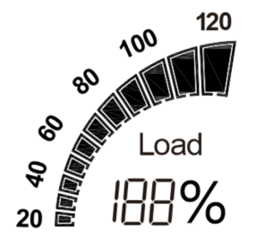 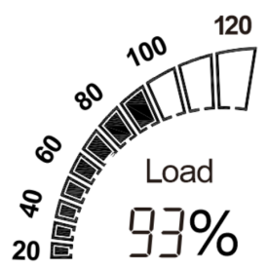

Note:

1), Under the measurement type conditions of three-phase four-wire 3CT, three-phase three-wire 3CT and single-phase two-wire 3CT, the effective phase number is equal to 3. Under the measurement type condition of three phase three-wire 2CT and two phase three-wire 2CT, the effective phase number is equal to 2.

2), The rated voltage is equal to the rated voltage of the secondary side * the rate of the voltage transformer.

3), The rated current is equal to the rated current of the secondary side * the rate of the current transformer.

4), For Example: Under the measurement type conditions of three-phase four-wire 3CT, suppose the rated voltage of the secondary side is 110V, the rated current of the secondary side is 5A, the rate of the voltage transformer is 100, and the rate of the current transformer is 40, then the rated voltage value is 110*100=11kV, and the rated current value is 5*40=200A, so the rated value of the apparent power is 3*11000*200=6600kVA.

5), Rated voltage of the secondary side defaults to 230V and rated current of the secondary side defaults to 5A. Both values can be set by communication commands. For specific register information, please refer to the relevant communication protocol documents of the product.

### 3.1.2. Digital I/O indicating icon

The digital I/O indicator icon is used to indicate the status of the digital I/O interface of the current power meter.

Figure 3-2: Digital I/O indicator icon



If the icon only shows the circle without the dot inside, it means the current state is OFF. If both circle and dot show, it means the current state is ON. As shown in Figure 3-2, DI-1 and DI-2 are ON states, DI-3 and DI-4 are OFF states, DO-1 is OFF states and DO-2 is ON states.

## 3.2. Multi-tariffs function

The multi-tariffs function refers to the function that the meter realizes time-sharing measurement of electric quantity. The power meter divides the 24 hours of a day into several time periods, and then specifies the rate number for each time period. Then the power meter accumulates the amount of electricity in time division according to the pre-divided time period, and stores it to the position of the rate number corresponding to each time period, so as to realize the function of time-division measurement of electricity.

The power meter used the method of the tariff number correlation to the starting time point to realize the tariff segment division. The power meter support up to 8 starting time points and up to 4 tariff segments (T1, T2, T3 and T4).

Figure 3-3: The starting time points of the tariff segment

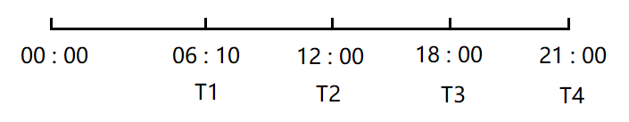

As shown in Figure 3-3, 06:10 designated as the start time of tariff 1 (T1), 12:00 designated as the start time of tariff 2 (T2), 18:00 designated as the start time of tariff 3 (T3), 21:00 designated as the start time of tariff 4 (T4), so tariff 1 time range is 06:10 to 12:00, tariff 2 time range is 12:00 to 18:00, tariff 3 time range is 18:00 to 21:00, tariff 4 time range is 21:00 to tomorrow 06:10.

Note: The tariff parameters can be set by pressing the button (Refer to step 5 in 4.5.7), also can be set by communication commands (Please refer to the relevant communication protocol document for the register address).

## 3.3. Demand calculation method

### 3.3.1. Fixed block interval

The block intervals are consecutive, the power meter calilates and updates the demand at the end of each interval.

Figure 3-4: Diagram of fixed block interval calculation method

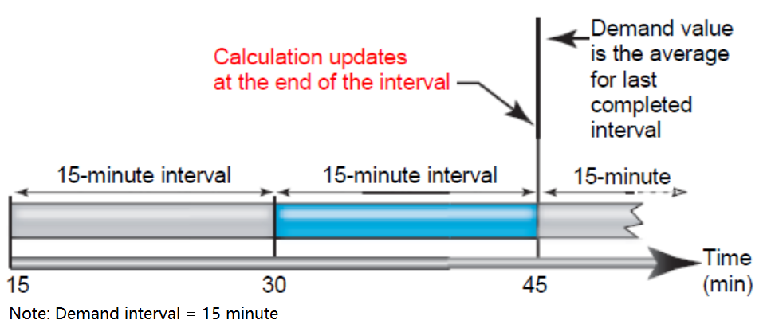

As shown in Figure 3-4, the first demand calculation is made at the 30th minute, and the demand calculation data is between the 15th and the 30th minute. At the 45th minute, do the second demand calculation, and the demand calculation data is between the 30th and the 45th minute.

### 3.3.2. Sliding block interval

The block intervals are sliding, the power meter calculates and update the demand at the sliding speed.

Figure 3-5: Diagram of sliding block interval calculation method

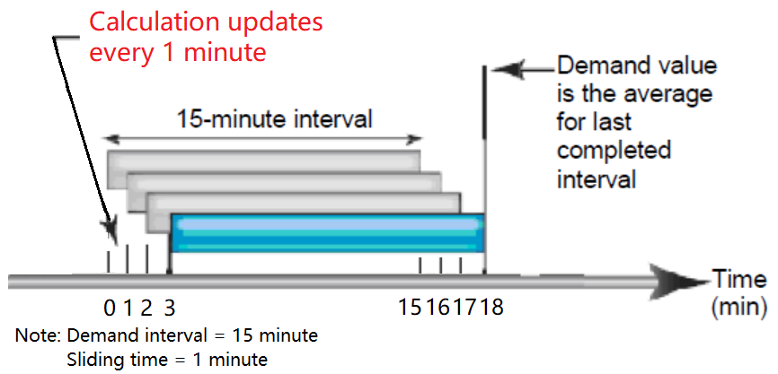

As shown in Figure 3-5, the first demand calculation is made at the 15th minute, and the demand calculation data is between the 0th and the 15th minute. At the 16th minute, do the second demand calculation, and the demand calculation data is between the 1th and the 16th minute. At the 17th minute, do the third demand calculation, and the demand calculation data is between the 2th and the 17th minute.

## 3.4. System current direction correction function

This function is to set the wiring direction of the CT of the current channel through internal processing of the power meter, without rewiring the CT in this process. In the process of wiring, if the current transformer is installed in the opposite direction or connected to the power meter in the opposite direction, the user can use this setting function to ensure that the current measured by the power meter is in the correct direction without rewiring the current transformer.

Note: This function can be set by pressing the button (Refer to step 3 in 4.5.4), also can be set by communication commands (Please refer to the relevant communication protocol document for the register address).

## 3.5. Description of energy display format

The energy display format of power meter is to automatically adjust the display effective digit according to the energy value. The change process of effective digit of energy display is shown as follows:

0.00 kWh/kvarh -> 999999.99 kWh/kvarh -> 1000000.0 kWh/kvarh -> 9999999.9 kWh/kvarh -> 10000000 kWh/kvarh -> 99999999 kWh/kvarh -> 100000.00 MWh/Mvarh -> 999999.99 MWh/Mvarh -> 1000000.0 MWh/Mvarh -> 9999999.9 MWh/Mvarh -> 10000000 MWh/Mvarh -> 99999999 MWh/Mvarh -> 0.00 kWh/kvarh.

**Chapter 4．Operation**

4.1. Power meter startup instructions

After the PAC5000 series products are properly wired and connected to the power supply, the products will first enter the self-test process, under which the LCD screen display sequence is shown as follows:

|  |  |  |
| --- | --- | --- |
| First screen display | Display full screen characters |  |
| Second screen display | Displays the software version number of the power meter |  |
| Third screen display | Display the results of the self-test |  |

## 4.2. LCD display area description

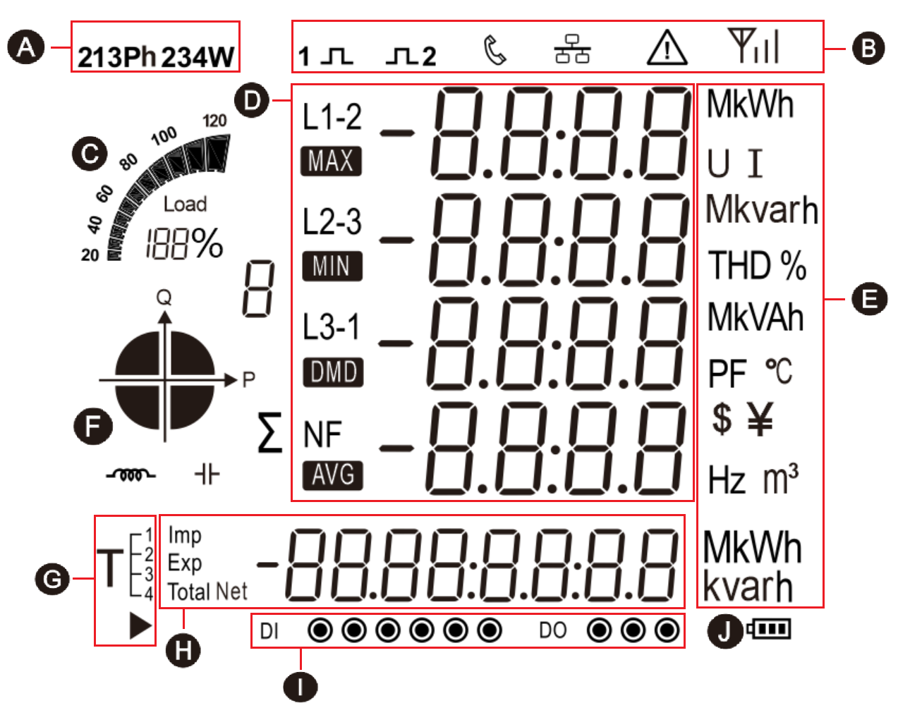

**A:** The power grid type icon represents the current measurement type of the power meter.

**B:** The status indicator icon for the power meter.

**C:** Bar graph for power indication.

**D:** Measured values.

**E:** An icon of a unit of measurement data.

**F:** Quadrant indicator icon indicating the quadrant of the current load.

**G:** Multi tariff icon indicating the tariff segment to which the current energy.  represents the tariff number displayed as the running tariff segment.

For example:  The figure on the left represents that the tariff 2 (T2) segment is running, and the accumulated energy will be counted into the corresponding energy area of tariff 2 (T2).

**H:** Energy data display area of the power meter.

**I:** An icon of digital I/O status for the power meter.

**J:** The battery status icon of the power meter indicates the state of the battery.

## 4.3. Button definition description

|  |  |  |  |
| --- | --- | --- | --- |
| **Button** | **Definition** | **Click** | **Press 3 second** |
|  | Button 1:  Escape key (Esc) | 1. In the setting screen or auxiliary screen: exit or return to the previous screen.  2. In the main display screen: page turning for parameters such as voltage and current. | Under the main display screen: enter the auxiliary display screen. |
|  | Button 2:  Up key  (Up) | 1. In the main display screen: view the power factor, maximum demand.  2. In the setting screen or auxiliary screen: scroll up to display the page or the increasing number. | Null |
|  | Button 3:  Down key  (Dn) | 1. In the main display screen: view the power information.  2. In the setting screen or auxiliary screen: scroll down to display the page or the decreasing number. | Null |
|  | Button 4:  Enter key  (Et) | 1. In the main display screen: view energy data and system time.  2. In the setting screen: right move the setting cursor. | 1. In the main display screen: enter the setting mode.  2. In the auxiliary display screen: confirm the auxiliary information to be viewed and enter the specific display screen.  3. In the setting screen: enter the setting state or carry out confirmation operation. |

## 4.4. Description of display screen

### 4.4.1. Main display screen

After the power meter is powered on and passes the self-test process, it will enter the main display screen. This screen is used to display the main measurement parameters and energy data of the power meter. Users can click the button to turn the page for viewing. Under the main display screen, the power meter will assign different parameter display for each button according to the different system types currently set. The logic diagram of display screen controlled by each button is shown below. Please refer to Appendix C for the specific display screen diagram.

1. Three-phase four-wire (3P4W)

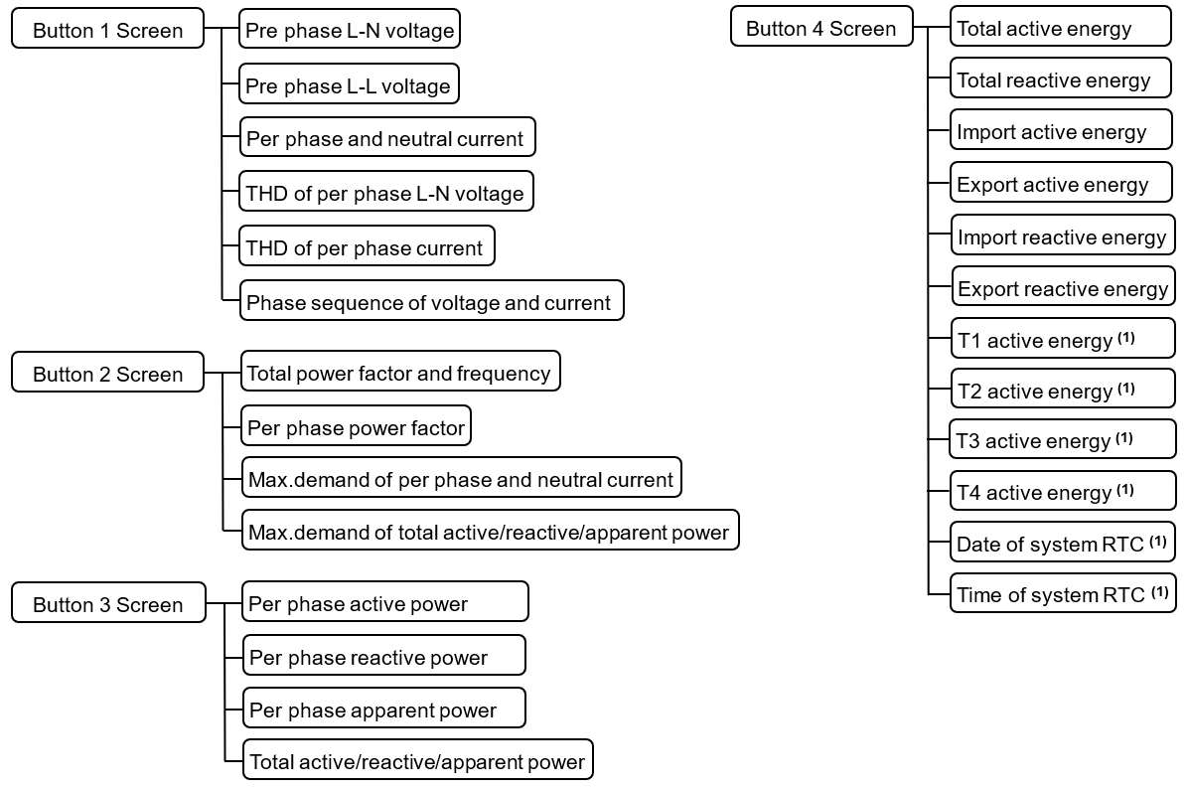

Note (1): This is only shown if the power meter is a multi tariff model, such as PAC5010 and PAC5110.

2. Three-phase three-wire 2CT (3P3W 2CT)

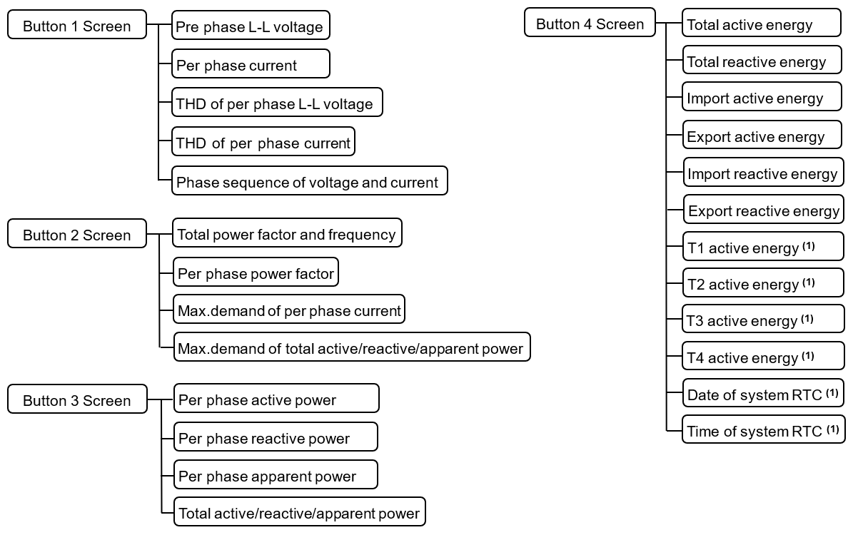

Note (1): This is only shown if the power meter is a multi tariff model, such as PAC5010 and PAC5110.

3. Three-phase three-wire 3CT (3P3W 3CT)

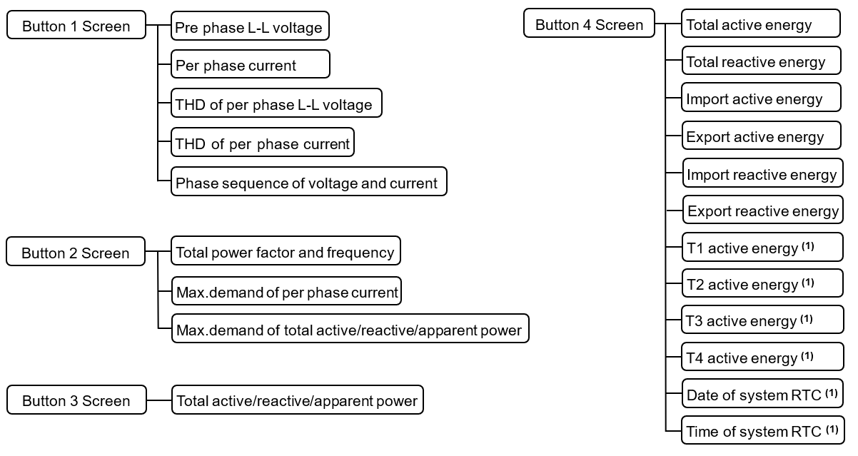

Note (1): This is only shown if the power meter is a multi tariff model, such as PAC5010 and PAC5110.

4. Single-phase two-wire (1P2W)

Note: In single-phase two-line mode, the measurement voltage input end is connected to the same voltage line, and the current input end can be connected to three current transformers to measure three different single-phase loads. Therefore, the product can be used as a product with a 3-channel measurement loop.

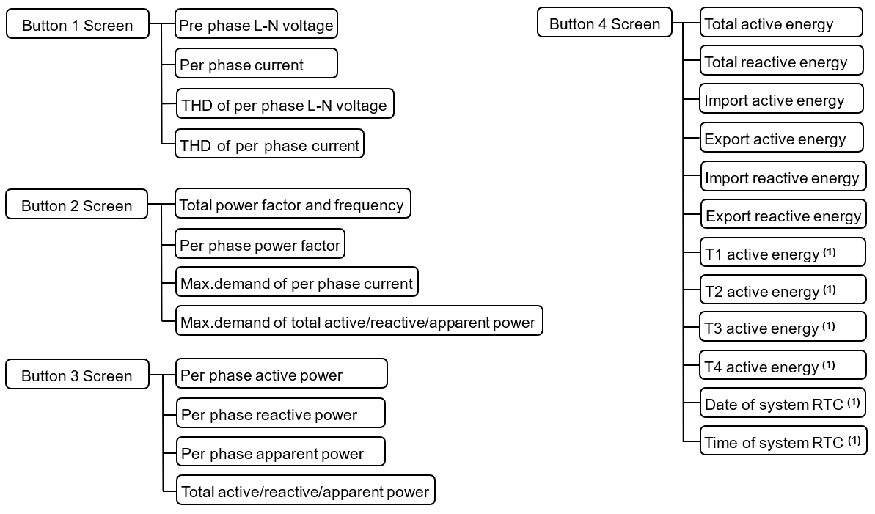

Note (1): This is only shown if the power meter is a multi tariff model, such as PAC5010 and PAC5110.

5. Two-phase three-wire (2P3W)

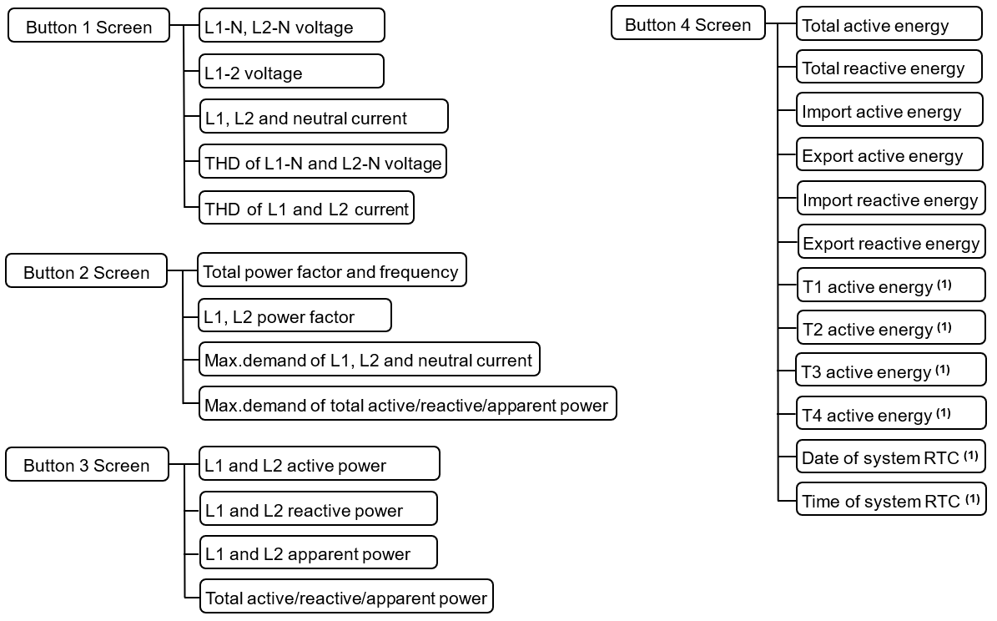

Note (1): This is only shown if the power meter is a multi tariff model, such as PAC5010 and PAC5110.

### 4.4.2. Auxiliary display screen

Under the main display screen, press button 1 for 3 second to enter the selection screen of auxiliary display. At this point, click button 2 or button 3 can be used to select the option of auxiliary information that needs to be viewed. Then press button 4 for 3 second to enter the specific data display screen of the selected auxiliary information option. After entering the specific auxiliary information display screen, you can turn the page by click the button 2 or button 3, and clcik the button 1 to return to the previous menu. Please refer to Appendix D for the detailed screen diagram of auxiliary information display.

**Note:** The auxiliary display screen supports two exit modes, namely, timed exit and manual exit. The register with the address [56 0B] can be set with the RS485 communication function to switch between these two modes.

1. Manual exit mode: the exit function can only be achieved by pressing the button 1. If you do not exit manually, you will always stay in the auxiliary display screen.

2. Timed exit mode: on the auxiliary display screen, if there is no keystroke operation within the set time, it will automatically exit and return to the main display screen. The set time is equal to the value set in the register with the address [56 0B]. The effective range is 0 to 255 seconds, 0 represents manual exit mode.

The display categories of the auxiliary display screen respectively include:

1). Per phase measurement data. (Not displayed under type 3P3W)

2). Maximum and minimum value data.

3). Individual harmonic distortion of voltage

4). Individual harmonic distortion of current

5). Extended information

The display logic diagram of the auxiliary display screen is shown below:

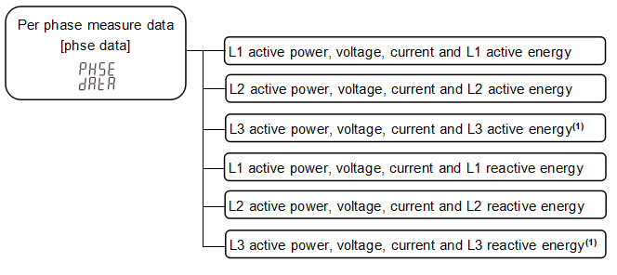

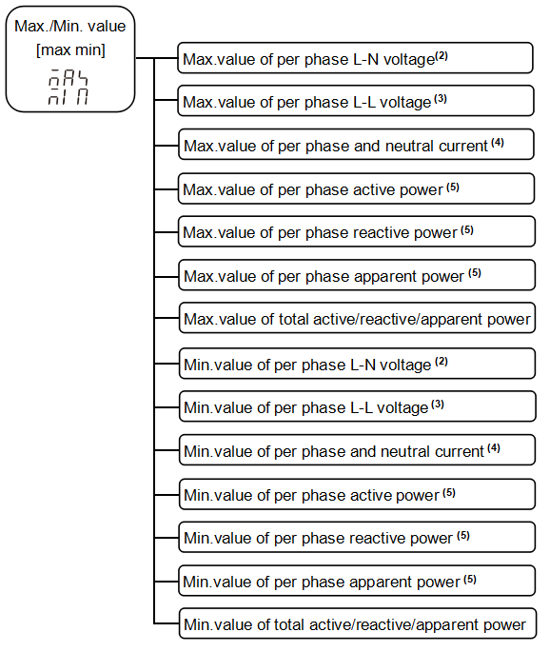

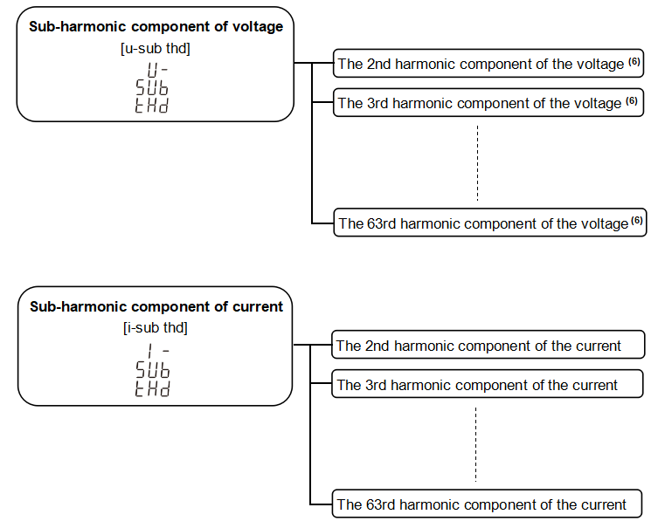

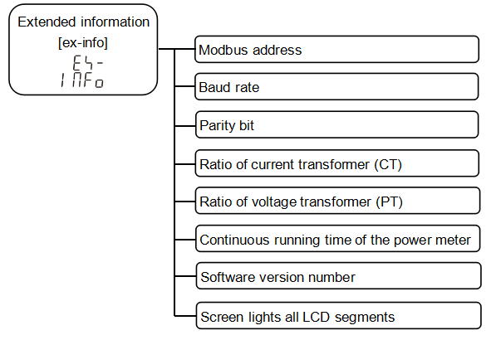

Note:

(1). It is not displayed in two-phase three-wire mode.

(2). It is not displayed in three-phase three-wire mode.

(3). It is not displayed in signle-phase three-wire mode.

(3). Neutral current is not displayed in three-phase three-wire mode

(5). It is not displayed in three-phase three-wire 3CT mode.

(6). In the three-phase three-wire mode, the L-L voltage harmonics are displayed, while in other modes, the L-N voltage harmonics are displayed.

## 4.5. Setting-up

The logical diagram of the parameter setting menu is as follows:

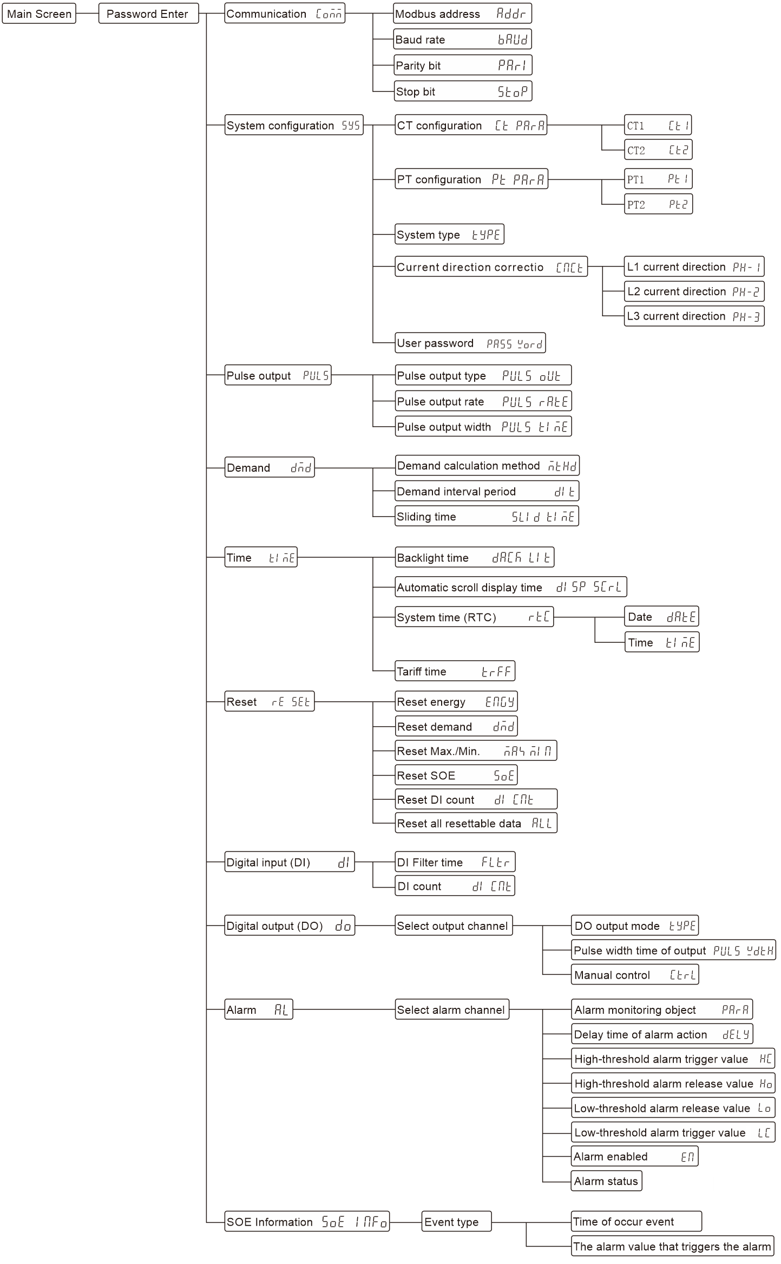

**How to enter the "Parameter setting Menu" screen:**

Step 1: In the main display screen, press button 4 for 3 second to enter the user password input mode.

**Note:** The user password input screen is shown in the figure on the right. 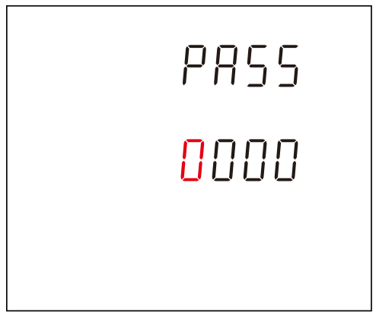

Step 2: Enter the correct user password and press button 4 for 3 second to confirm.

**How to enter a password:**

A: Click button 2 or 3 to increase or decrease the number of flashing bits.

B: Click button 4 to move the flashing position to the right.

C: After entering the correct password, press button 4 for confirmation. If the password is verified correctly, the power meter will enter the screen of "Parameter Setting menu".

Note: Under the user password input screen, can click button 1 to return to the main display screen. If there is no button operation in more than 1 minute under this screen, the power meter will automatically return to the main display screen.

### 4.5.1. Set communication class parameters

Communication parameters include: Modbus address, baud rate, parity bit, stop bit.

|  |  |
| --- | --- |
| 1. After entering the "Parameter Setting Menu" screen, select the L-01 setting screen (as shown in the figure below), and then press button 4 for 3 second to enter the communication parameter setting screen. | |
| 2. Setting modbus address (L-01.01 setting screen) | |
|  | Modbus address setting range: 001 to 247, default is 001.  Press button 4 for 3 second to enter the setting state, and the digit of the setting becomes the flashing state.  Click button 1 to return to the previous level setup menu. |
|  | Click button 2 or 3 to increase or decrease the number of set bits.  Click button 4 can be moved the set bits to the right.  Press button 4 for 3 second to confirm the setting. The power meter will save the setting value and exit the setting state.  Click button 1 to exit the setting state without saving the setting parameters. |
| 3. Setting baud rate (L-01.02 setting screen) | |
|  | Baud rate can be set: 1200, 2400, 4800, 9600, 19200, 38400 bps, default is 9600bps.  Press button 4 for 3 second to enter the setting state, and the digit of the setting becomes the flashing state.  Click button 1 to return to the previous level setup menu. |
|  | Click button 2 or 3 to select the baud rate.  Press button 4 for 3 second to confirm the setting. The power meter will save the setting value and exit the setting state.  Click button 1 to exit the setting state without saving the setting parameters. |
| 4. Setting parity bit (L-01.03 setting screen) | |
|  | Parity bit can be set: None, Even, Odd, default is None.  Press button 4 for 3 second to enter the setting state, and the character of the setting becomes the flashing state.  Click button 1 to return to the previous level setup menu. |
|  | Click button 2 or 3 to select the parity bit.  Press button 4 for 3 second to confirm the setting. The power meter will save the setting value and exit the setting state.  Click button 1 to exit the setting state without saving the setting parameters. |
| 5. Setting stop bit (L-01.04 setting screen) | |
|  | Stop bit can be set: 1 or 2, default is 1.  Press button 4 for 3 second to enter the setting state, and the digit of the setting becomes the flashing state.  Click button 1 to return to the previous level setup menu.  **Note:** The stop bit can only be set to 2 if the check bit is equal to None. |
|  | Click button 2 or 3 to select the stop bit.  Press button 4 for 3 second to confirm the setting. The power meter will save the setting value and exit the setting state.  Click button 1 to exit the setting state without saving the setting parameters. |

### 4.5.2. Set CT class parameters

CT parameters include: primary side value (CT1) and secondary side value (CT2) of the current transformer.

|  |  |
| --- | --- |
| 1. After entering the "Parameter Setting Menu" screen, select the L-02 setting screen (as shown in the figure below), and then press button 4 for 3 second to enter the CT parameter setting screen. | |
| 2. Select the L-02.01 setting screen (as shown in the figure below), and then press button 4 for 3 second to enter the CTclass parameters setting screen. | |
| 2.1. Setting CT1 (L-02.01.01 setting screen) | |
|  | CT1 setting range: 1 to 9999A, default is 5A.  Press button 4 for 3 second to enter the setting state, and the digit of the setting becomes the flashing state.  Click button 1 to return to the previous level setup menu. |
|  | Click button 2 or 3 to increase or decrease the number of set bits.  Click button 4 can be moved the set bits to the right.  Press button 4 for 3 second to confirm the setting. The power meter will save the setting value and exit the setting state.  Click button 1 to exit the setting state without saving the setting parameters. |
| 2.2. Setting CT2 (L-02.01.02 setting screen) | |
|  | CT2 can be set: 1A or 5A, default is 5A.  Press button 4 for 3 second to enter the setting state, and the digit of the setting becomes the flashing state.  Click button 1 to return to the previous level setup menu. |
|  | Click button 2 or 3 to select the CT2.  Press button 4 for 3 second to confirm the setting. The power meter will save the setting value and exit the setting state.  Click button 1 to exit the setting state without saving the setting parameters. |

### 4.5.3. Set PT class parameters

PT parameters include: primary side value (PT1) and secondary side value (PT2) of the voltage transformer.

|  |  |
| --- | --- |
| 1. After entering the "Parameter Setting Menu" screen, select the L-02 setting screen (as shown in the figure below), and then press button 4 for 3 second to enter the PT parameter setting screen. | |
| 2. Select the L-02.02 setting screen (as shown in the figure below), and then press button 4 for 3 second to enter the PTclass parameters setting screen. | |
| 2.1. Setting PT1 (L-02.02.01 setting screen) | |
|  | PT1 setting range: 30 to 600000V, default is 230V.  Press button 4 for 3 second to enter the setting state, and the digit of the setting becomes the flashing state.  Click button 1 to return to the previous level setup menu. |
|  | Click button 2 or 3 to increase or decrease the number of set bits.  Click button 4 can be moved the set bits to the right.  Press button 4 for 3 second to confirm the setting. The power meter will save the setting value and exit the setting state.  Click button 1 to exit the setting state without saving the setting parameters. |
| 2.2. Setting PT2 (L-02.02.02 setting screen) | |
|  | PT2 setting range: 30 to 600V, default is 230V.  Press button 4 for 3 second to enter the setting state, and the digit of the setting becomes the flashing state.  Click button 1 to return to the previous level setup menu. |
|  | Click button 2 or 3 to increase or decrease the number of set bits.  Click button 4 can be moved the set bits to the right.  Press button 4 for 3 second to confirm the setting. The power meter will save the setting value and exit the setting state.  Click button 1 to exit the setting state without saving the setting parameters. |

### 4.5.4. Set system class parameters

System class parameters include: system type, system current direction correction, user password.

|  |  |
| --- | --- |
| 1. After entering the "Parameter Setting Menu" screen, select the L-02 setting screen (as shown in the figure below), and then press button 4 for 3 second to enter the system class parameter setting screen. | |
| 2. Setting system type (L-02.03 setting screen) | |
|  | The system type supported by the power meter includes the five types: 1P2W 3CT, 2P3W 2CT, 3P3W 2CT, 3P4W 3CT, 3P3W 3CT.  Press button 4 for 3 second to enter the setting state, and the character of the setting becomes the flashing state.  Click button 1 to return to the previous level setup menu. |
|  | The corresponding relationship between the character of the setting option and the actual measurement wire type is shown in Table 1 below.  Note: To set the character of the option and the corresponding relationship of the system type, please refer to Table 4-1. |
| 3. Setting system current direction correction (L-02.04 setting screen) | |
|  | Press button 4 for 3 second to enter the next level setting menu.  Click button 1 to return to the previous level setup menu. |
| 3.1. Set L1 current direction correction (L-02.04.01 setting screen) | |
|  | L1 current direction correction can be set: forward or reverse, default is forward.  Click button 3 to scroll down to the Settings screen of L2.  Press button 4 for 3 second to enter the setting state, and the character of the setting becomes the flashing state.  Click button 1 to return to the previous level setup menu. |
|  | Click button 2 or 3 to select the current direction.  Press button 4 for 3 second to confirm the setting. The power meter will save the setting value and exit the setting state.  Click button 1 to exit the setting state without saving the setting parameters.  **Note:**  represents forward,  represents reverse. |
| 3.2. Setting L2 current direction correction (L-02.04.02 setting screen) | |
|  | L2 current direction correction can be set: forward or reverse, default is forward.  Click button 2 to scroll up to the Settings screen of L1.  Click button 3 to scroll down to the Settings screen of L3.  Press button 4 for 3 second to enter the setting state, and the character of the setting becomes the flashing state.  Click button 1 to return to the previous level setup menu. |
|  | Click button 2 or 3 to select the current direction.  Press button 4 for 3 second to confirm the setting. The power meter will save the setting value and exit the setting state.  Click button 1 to exit the setting state without saving the setting parameters.  **Note:**  represents forward,  represents reverse. |
| 3.3. Setting L3 current direction correction (L-02.04.03 setting screen) | |
|  | L3 current direction correction can be set: forward or reverse, default is forward.  Click button 2 to scroll up to the Settings screen of L2.  Press button 4 for 3 second to enter the setting state, and the character of the setting becomes the flashing state.  Click button 1 to return to the previous level setup menu. |
|  | Click button 2 or 3 to select the current direction.  Press button 4 for 3 second to confirm the setting. The power meter will save the setting value and exit the setting state.  Click button 1 to exit the setting state without saving the setting parameters.  **Note:**  represents forward,  represents reverse. |
| 4. Setting user password (L-02.05 setting screen) | |
|  | User password setting range:0000 to 9999, default is 0000.  Press button 4 for 3 second to enter the setting state, and the digit of the setting becomes the flashing state.  Click button 1 to return to the previous level setup menu. |
|  | Click button 2 or 3 to increase or decrease the number of set bits.  Click button 4 can be moved the set bits to the right.  Press button 4 for 3 second to confirm the setting. The power meter will save the setting value and exit the setting state.  Click button 1 to exit the setting state without saving the setting parameters. |

Table 4-1: List of system type

|  |  |  |  |  |  |
| --- | --- | --- | --- | --- | --- |
| **Character** | **System type** | **Character** | **System type** | **Character** | **System type** |
|  | 1P2W 3CT |  | 2P2W 2CT |  | 3P3W 2CT |
|  | 3P4W 3CT |  | 3P3W 3CT |  | |

### 4.5.5. Set pulse output class parameters

Pulse output class parameters include: pulse output type, pulse output rate and pulse output width.

|  |  |
| --- | --- |
| 1. After entering the "Parameter Setting Menu" screen, select the L-03 setting screen (as shown in the figure below), and then press button 4 for 3 second to enter the pulse output class parameter setting screen. | |
| 2. Setting pulse output type (L-03.01 setting screen) | |
|  | The type of energy represented by the pulse output.  Options that can be set: total active energy, import active energy, export active energy, total reactive energy, import reactive energy, export reactive energy, default is total reactive energy.  Press button 4 for 3 second to enter the setting state, and the character of the setting becomes the flashing state.  Click button 1 to return to the previous level setup menu. |
|  | Click button 2 or 3 to select the pulse output type.  Press button 4 for 3 second to confirm the setting. The power meter will save the setting value and exit the setting state.  Click button 1 to exit the setting state without saving the setting parameters.  Note: To set the character of the option and the corresponding relationship of the pulse output type, please refer to Table 4-2. |
| 3. Setting pulse output rate (L-03.02 setting screen) | |
|  | Pulse output rate can be set: 0.001, 0.01, 0.1, 1, 10, 100, 1000, default is 0.01.  Press button 4 for 3 second to enter the setting state, and the character of the setting becomes the flashing state.  Click button 1 to return to the previous level setup menu.  **Note:** Digital representation of pulse output rate: how much kWh/ kVARh is each pulse. Example: Setting the pulse output rate to 0.1 means that each output pulse is equal to 0.1kwh /kvarh. |
|  | Click button 2 or 3 to select the pulse output rate.  Press button 4 for 3 second to confirm the setting. The power meter will save the setting value and exit the setting state.  Click button 1 to exit the setting state without saving the setting parameters. |
| 4. Setting pulse output width (L-03.03 setting screen) | |
|  | The pulse output width represents the effective duration of the pulse output.  Options that can be set: 60, 100, 200, unit is ms, default is 100ms.  Press button 4 for 3 second to enter the setting state, and the digit of the setting becomes the flashing state.  Click button 1 to return to the previous level setup menu. |
|  | Click button 2 or 3 to select the pulse output width.  Press button 4 for 3 second to confirm the setting. The power meter will save the setting value and exit the setting state.  Click button 1 to exit the setting state without saving the setting parameters. |

Table 4-2: List of pulse output type

|  |  |  |  |  |  |
| --- | --- | --- | --- | --- | --- |
| **Character** | **Pulse output type** | **Character** | **Pulse output type** | **Character** | **Pulse output type** |
|  | Total active energy |  | Import active energy |  | Export active energy |
|  | Total reactive energy |  | Import reactive energy |  | Export reactive energy |

### 4.5.6. Set demand class parameters

Demand class parameters include: demand calculation method, demand interval period and sliding time.

|  |  |
| --- | --- |
| 1. After entering the "Parameter Setting Menu" screen, select the L-04 setting screen (as shown in the figure below), and then press button 4 for 3 second to enter the demand class parameter setting screen. | |
| 2. Setting demand calculation method (L-04.01 setting screen) | |
|  | Demand calculation method can be set: fix block interval and sliding block interval, default is sliding block interval.  Press button 4 for 3 second to enter the setting state, and the character of the setting becomes the flashing state.  Click button 1 to return to the previous level setup menu. |
|  | Click button 2 or 3 to select the demand calculation method.  Press button 4 for 3 second to confirm the setting. The power meter will save the setting value and exit the setting state.  Click button 1 to exit the setting state without saving the setting parameters.  **Note:**  represents fix block interval,  represents sliding block interval. |
| 3. Setting demand interval period (L-04.02 setting screen) | |
|  | Demand interval period can be set: 0, 5, 8, 10, 15, 30, 60, unit is minute, default is 60 minutes.  Press button 4 for 3 second to enter the setting state, and the digit of the setting becomes the flashing state.  Click button 1 to return to the previous level setup menu.  Note:  1. If the demand interval period is set to 0 minutes, then the demand is updated every second.  2. If you need to set other values between 0 and 60 minutes, use the communication command to do so. |
|  | Click button 2 or 3 to select the demand interval period.  Press button 4 for 3 second to confirm the setting. The power meter will save the setting value and exit the setting state.  Click button 1 to exit the setting state without saving the setting parameters. |
| 3. Setting sliding time (L-04.03 setting screen) | |
|  | Sliding time setting range: 1 to (demand interval period), unit is minutes, default is 1 minute.  Press button 4 for 3 second to enter the setting state, and the digit of the setting becomes the flashing state.  Click button 1 to return to the previous level setup menu.  **Note:** This setting menu will only be displayed if the demand calculation method is set to sliding block interval. |
|  | Click button 2 or 3 to increase or decrease the number of set bits.  Click button 4 can be moved the set bits to the right.  Press button 4 for 3 second to confirm the setting. The power meter will save the setting value and exit the setting state.  Click button 1 to exit the setting state without saving the setting parameters. |

### 4.5.7. Set time class parameters

Time class parameters include: backlight time, automatic scroll display time, System time (RTC) and Tariff time.

|  |  |
| --- | --- |
| 1. After entering the "Parameter Setting Menu" screen, select the L-05 setting screen (as shown in the figure below), and then press button 4 for 3 second to enter the time class parameter setting screen. | |
| 2. Setting backlight time (L-05.01 setting screen) | |
|  | Backlight time can be set: on, off, 5, 10, 30, 60, 120, unit is minute, default is 60 minutes.  Press button 4 for 3 second to enter the setting state, and the character of the setting becomes the flashing state.  Click button 1 to return to the previous level setup menu.  Note:  1. On means the backlight is always on, and off means the backlight is always off.  2. If you need to set other values within 120 minutes, use the communication command to do so. |
|  | Click button 2 or 3 to select the backlight time.  Press button 4 for 3 second to confirm the setting. The power meter will save the setting value and exit the setting state.  Click button 1 to exit the setting state without saving the setting parameters.  **Note:** That means is on.  That means is off. |
| 3. Setting automatic scroll display time (L-05.02 setting screen) | |
|  | Automatic scroll display time set range: 0 to 255, unit is second, default is 0 second.  Press button 4 for 3 second to enter the setting state, and the digit of the setting becomes the flashing state.  Click button 1 to return to the previous level setup menu.  **Note:**  1. Automatic scroll display time refers to the time interval of automatic page turning display on the main display screen.  2. Automatic scroll display time is 0, means no automatic wheel display |
|  | Click button 2 or 3 to increase or decrease the number of set bits.  Click button 4 can be moved the set bits to the right.  Press button 4 for 3 second to confirm the setting. The power meter will save the setting value and exit the setting state.  Click button 1 to exit the setting state without saving the setting parameters. |
| 4. Setting system time (RTC) (L-05.03 setting screen) | |
|  | Press button 4 for 3 second to enter the next level setting menu.  Click button 1 to return to the previous level setup menu. |
| 4.1. Setting date of RTC (L-05.03.01 setting screen) | |
|  | Click button 3 to scroll down to the time setting screen.  Press button 4 for 3 second to enter the setting state, and the character of the setting becomes the flashing state.  Click button 1 to return to the previous level setup menu. |
|  | Click button 2 or 3 to increase or decrease the number of set bits.  Click button 4 can be moved the set bits to the right.  Press button 4 for 3 second to confirm the setting. The power meter will save the setting value and exit the setting state.  Click button 1 to exit the setting state without saving the setting parameters. |
| 4.2. Setting time of RTC (L-05.03.02 setting screen) | |
|  | Click button 2 to scroll up to the date setting screen.  Press button 4 for 3 second to enter the setting state, and the character of the setting becomes the flashing state.  Click button 1 to return to the previous level setup menu. |
|  | Click button 2 or 3 to increase or decrease the number of set bits.  Click button 4 can be moved the set bits to the right.  Press button 4 for 3 second to confirm the setting. The power meter will save the setting value and exit the setting state.  Click button 1 to exit the setting state without saving the setting parameters. |
| 5. Setting tariff time (L-05.04 setting screen) | |
|  | Press button 4 for 3 second to enter the next level setting menu.  Click button 1 to return to the previous level setup menu. |
| 5.1. Setting the start time of the tariff segment (L-05.04.01 to L-05.04.08 setting screen) | |
|  | Click button 2 or 3 to select the time starting point that needs to be set.  Press button 4 for 3 second to enter the setting state, and the character of the setting becomes the flashing state.  Click button 1 to return to the previous level setup menu.  **Note:**  1. The number displayed in the second line of the screen represents the sequence number of the selected starting time point. The meter supports 8 starting time points and 4 tariff segments.  2. The character displayed in the third line of the screen represents the starting time of the tariff segment (format is hours: minutes).  3. The power meter supports 4 tariff segments.  That means tariff segment is tariff 1 (T1).  That means tariff segment is tariff 2 (T2).  That means tariff segment is tariff 3 (T3).  That means tariff segment is tariff 4 (T4). |
|  | Click button 2 or 3 to increase or decrease the number of set bits.  Click button 4 can be moved the set bits to the right.  Press button 4 for 3 second to confirm the setting. The power meter will save the setting value and exit the setting state.  Click button 1 to exit the setting state without saving the setting parameters.  **Note:** If the time point is not needed (no link tariff segment), the tariff number needs to be set to 0. |

### 4.5.8. Reset

The power meter supports button reset operations for the data types is: energy data, Max. Demand, DI count, Max./Min. value, SOE information.

|  |  |
| --- | --- |
| 1. After entering the "Parameter Setting Menu" screen, select the L-06 setting screen (as shown in the figure below), and then press button 4 for 3 second to enter the reset parameter setting screen. | |
| 2. Select the data type that need to be reset (L-06.01 to L-06.06 setting screen) | |
|  | Click button 2 or 3 to select the data type that needs to be reset.  Press button 4 for 3 second to enter the reset state, and the character of the reset data becomes the flashing state.  Click button 1 to return to the previous level setup menu.  **Note:** To reset the character of the option and the corresponding relationship of the reset data, please refer to Table 4-3. |
|  | Press button 4 for 3 second to confirm the operation, and the power meter will reset the selected type of data.  Click button 1 to exit the reset state, and do not reset the selected reset option. |

Table 4-3: List of reset data type

|  |  |  |  |  |  |
| --- | --- | --- | --- | --- | --- |
| **Character** | **Reset data type** | **Character** | **Reset data type** | **Character** | **Reset data type** |
|  | All energy data |  | Max. Demand |  | DI count |
|  | Max./Min. value |  | SOE information |  | All resettable data |

### 4.5.9. Set digital input (DI) class parameters

Digital input (DI) class parameters include: DI filter time and DI count.

|  |  |
| --- | --- |
| 1. After entering the "Parameter Setting Menu" screen, select the L-07 setting screen (as shown in the figure below), and then press button 4 for 3 second to enter the digital input (DI) class parameter setting screen. | |
| 2. Setting DI filter time (L-07.01 setting screen) | |
|  | DI filter time set range: 0 to 255, unit is ms, default is 100ms.  Press button 4 for 3 second to enter the setting state, and the character of the setting becomes the flashing state.  Click button 1 to return to the previous level setup menu. |
|  | Click button 2 or 3 to increase or decrease the number of set bits.  Click button 4 can be moved the set bits to the right.  Press button 4 for 3 second to confirm the setting. The power meter will save the setting value and exit the setting state.  Click button 1 to exit the setting state without saving the setting parameters. |
| 3. View DI count (L-07.02 view screen) | |
|  | Press button 4 for 3 second to enter the DI count value view screen.  Click button 1 to return to the previous level setup menu. |
|  | Click button 2 or 3 to select the DI channel.  Click button 1 to return to the previous level setup menu.  **Note:** The power meter provides four digital input channels (DI-1, DI-2, DI-3 and DI-4). |

### 4.5.10. Set digital output (DO) class parameters

Digital output (DO) class parameters include: output mode, pulse width time of output and manual control.

|  |  |
| --- | --- |
| 1. After entering the "Parameter Setting Menu" screen, select the L-08 setting screen (as shown in the figure below), and then press button 4 for 3 second to enter the digital output (DO) class parameter setting screen. | |
| 2. Select DO output channel (L-08.01 to L-08.02 setting screen) | |
|  | Click button 2 or 3 select the digital output channel.  Press button 4 for 3 second to enter the parameter setting menu of the digital output channel.  Press the No. 1 button to return to the previous level menu. |
| 3. Setting DO output mode (L-08.0*.01 setting screen) | |
|  | DO output mode can be set: level output mode and pulse output mode, default is level mode.  Press button 4 for 3 second to enter the setting state, and the character of the setting becomes the flashing state.  Click button 1 to return to the previous level setup menu. |
|  | Click button 2 or 3 to select the DO output mode.  Press button 4 for 3 second to confirm the setting. The power meter will save the setting value and exit the setting state.  Click button 1 to exit the setting state without saving the setting parameters.  **Note:**  That means level output mode.  That means pulse output mode. |
| 4. Setting pulse width time of DO output (L-08.0*.02 setting screen) | |
|  | pulse width time of DO output set range: 50 to 3000, unit is ms, default is 1000ms.  Press button 4 for 3 second to enter the setting state, and the digit of the setting becomes the flashing state.  Click button 1 to return to the previous level setup menu.  **Note:** Only when the digital output (DO) is set to pulse output mode, this Settings screen will appear. |
|  | Click button 2 or 3 to increase or decrease the number of set bits.  Click button 4 can be moved the set bits to the right.  Press button 4 for 3 second to confirm the setting. The power meter will save the setting value and exit the setting state.  Click button 1 to exit the setting state without saving the setting parameters. |
| 5. Setting manual control of DO (L-08.0*.03 setting screen) | |
|  | The manual control operation screen of digital output (DO) can control the switch of relay to ON or OFF state.  Press 3Sbutton 4 to enter the manual control state, and the character of the control option becomes the flashing state.  Click button 1 to return to the previous level setup menu.  **Note:** ON means relay is closed, OFF means relay is open. |
|  | Click button 2 or 3 keys to select the state of the relay.  Press button 4 for 3 second for confirmation, and the meter will control the relay according to the selected relay state.  Click button 1 to exit the manual control state without any operation on the relay.  **Note:**  That means open, relay is OFF status.  That means close, relay is ON status. |

### 4.5.11. Set alarm (AL) class parameters

Alarm (AL) class parameters include: alarm monitoring object, delay time of alarm action, high-threshold alarm trigger value (HC), high-threshold alarm release value (HO), low threshold alarm release value (LO), low threshold alarm trigger value (LC), alarm enabled and alarm status.

|  |  |
| --- | --- |
| 1. After entering the "Parameter Setting Menu" screen, select the L-09 setting screen (as shown in the figure below), and then press button 4 for 3 second to enter the alarm (AL) class parameter setting screen. | |
| 2. Select Alarm (AL) channel (L-09.01 to L-09.02 setting screen) | |
|  | Click button 2 or 3 select the alarm channel.  Press button 4 for 3 second to enter the parameter setting menu of the alarm channel.  Press the No. 1 button to return to the previous level menu.  **Note:** AL-1 link to DO-1, AL-2 link to DO-2. |
| 3. Setting alarm monitoring object (L-09.0*.01 setting screen) | |
|  | The power meter has 37 alarm monitoring objects, the optional types of alarm monitoring objects are shown in Table 4-4 below.  Press button 4 for 3 second to enter the setting state, and the character of the setting becomes the flashing state.  Click button 1 to return to the previous level setup menu. |
|  | Click button 2 or 3 to select the alarm monitoring objects.  Press button 4 for 3 second to confirm the setting. The power meter will save the setting value and exit the setting state.  Click button 1 to exit the setting state without saving the setting parameters. |
| 4. Setting delay time of alarm action (L-09.0*.02 setting screen) | |
|  | Delay time of alarm action set range: 0 to 9999, unit is ms, default is 200ms.  If the delay time is set to 0, when an alarm occurs, the alarm action will be executed immediately without delay.  Press button 4 for 3 second to enter the setting state, and the digit of the setting becomes the flashing state.  Click button 1 to return to the previous level setup menu. |
|  | Click button 2 or 3 to increase or decrease the number of set bits.  Click button 4 can be moved the set bits to the right.  Press button 4 for 3 second to confirm the setting. The power meter will save the setting value and exit the setting state.  Click button 1 to exit the setting state without saving the setting parameters. |
| 5. Setting high-threshold alarm trigger value (HC) (L-09.0*.03 setting screen) | |
|  | Press button 4 for 3 second to enter the setting state, and the digit of the setting becomes the flashing state.  Click button 1 to return to the previous level setup menu.  **Note:** High-threshold alarm trigger values support signed values. |
|  | Click button 2 or 3 to increase or decrease the number of set bits.  Click button 4 can be moved the set bits to the right.  Press button 4 for 3 second to confirm the setting. The power meter will save the setting value and exit the setting state.  Click button 1 to exit the setting state without saving the setting parameters.  **Note:**  1. When the first number is equal to 0 and in the setting state, click button 3 to switch the number to a negative number, click button 2 to switch the number to a positive number.  2. Click button 4 to move the setting bit. When it moves to the fourth digit, click button 4 again, and the setting bit will switch to the setting of units, which can be set at this time. |
| 6. Setting high-threshold alarm release value (HO) (L-09.0*.04 setting screen) | |
|  | Press button 4 for 3 second to enter the setting state, and the digit of the setting becomes the flashing state.  Click button 1 to return to the previous level setup menu.  **Note:** High-threshold alarm release values support signed values. |
|  | Click button 2 or 3 to increase or decrease the number of set bits.  Click button 4 can be moved the set bits to the right.  Press button 4 for 3 second to confirm the setting. The power meter will save the setting value and exit the setting state.  Click button 1 to exit the setting state without saving the setting parameters.  **Note:**  1. When the first number is equal to 0 and in the setting state, click button 3 to switch the number to a negative number, click button 2 to switch the number to a positive number.  2. Click button 4 to move the setting bit. When it moves to the fourth digit, click button 4 again, and the setting bit will switch to the setting of units, which can be set at this time. |
| 7. Setting low-threshold alarm release value (LO) (L-09.0*.05 setting screen) | |
|  | Press button 4 for 3 second to enter the setting state, and the digit of the setting becomes the flashing state.  Click button 1 to return to the previous level setup menu.  **Note:** Low-threshold alarm release values support signed values. |
|  | Click button 2 or 3 to increase or decrease the number of set bits.  Click button 4 can be moved the set bits to the right.  Press button 4 for 3 second to confirm the setting. The power meter will save the setting value and exit the setting state.  Click button 1 to exit the setting state without saving the setting parameters.  **Note:**  1. When the first number is equal to 0 and in the setting state, click button 3 to switch the number to a negative number, click button 2 to switch the number to a positive number.  2. Click button 4 to move the setting bit. When it moves to the fourth digit, click button 4 again, and the setting bit will switch to the setting of units, which can be set at this time. |
| 8. Setting low-threshold alarm trigger value (LC) (L-09.0*.06 setting screen) | |
|  | Press button 4 for 3 second to enter the setting state, and the digit of the setting becomes the flashing state.  Click button 1 to return to the previous level setup menu.  **Note:** Low-threshold alarm trigger values support signed values. |
|  | Click button 2 or 3 to increase or decrease the number of set bits.  Click button 4 can be moved the set bits to the right.  Press button 4 for 3 second to confirm the setting. The power meter will save the setting value and exit the setting state.  Click button 1 to exit the setting state without saving the setting parameters.  **Note:**  1. When the first number is equal to 0 and in the setting state, click button 3 to switch the number to a negative number, click button 2 to switch the number to a positive number.  2. Click button 4 to move the setting bit. When it moves to the fourth digit, click button 4 again, and the setting bit will switch to the setting of units, which can be set at this time. |
| 9. Setting alarm enabled (L-09.0*.07 setting screen) | |
|  | Alarm enables can be set: ON and OFF.  ON means turn on alarm function, OFF means turn off alarm function.  Press button 4 for 3 second to enter the setting state, and the character of the setting becomes the flashing state.  Click button 1 to return to the previous level setup menu. |
|  | Click button 2 or 3 to select the alarm enable value.  Press button 4 for 3 second to confirm the setting. The power meter will save the setting value and exit the setting state.  Click button 1 to exit the setting state without saving the setting parameters. |
| 10. View alarm status (L-09.0*.08 view screen) | |
|  | View the alarm status of the current alarm channel.  Click button 1 to return to the previous level setup menu.  That means the alarm status is release, there is no alarm.  That means the alarm status is high-threshold alarm.  That means the alarm status is low-threshold alarm.  That means both high-threshold and low-threshold alarms occur in the monitoring object. It may occur only when the monitoring object is per phase parameter.  **Note:** This screen can only be viewed. |

Table 4-4: List of alarm monitoring objects

|  |  |  |  |  |  |
| --- | --- | --- | --- | --- | --- |
| **Character** | **Alarm monitoring objects** | **Character** | **Alarm monitoring objects** | **Character** | **Alarm monitoring objects** |
|  | Phase 1 line to neutral volts. |  | L1 active power |  | Phase 2 power factor. |
|  | Phase 2 line to neutral volts. |  | L2 active power |  | Phase 3 power factor . |
|  | Phase 3 line to neutral volts. |  | L3 active power |  | Total system power factor. |
|  | Average line to neutral volts. |  | Total active power |  | Frequency of supply voltages. |
|  | Line 1 to Line 2 volts. |  | L1 reactive power |  | Line to neutral voltage of per phase |
|  | Line 2 to Line 3 volts. |  | L2 reactive power |  | Line to line voltage of per phase |
|  | Line 3 to Line 1 volts. |  | L3 reactive power |  | Current of per phase |
|  | Average line to line volts. |  | Total reactive power |  | Active power of per phase |
|  | Phase 1 current. |  | L1 apparent power |  | Reactive power of per phase |
|  | Phase 2 current. |  | L2 apparent power |  | Apparent power of per phase |
|  | Phase 3 current. |  | L3 apparent power |  | Power factor of per phase |
|  | Average line current. |  | Total apparent power |  | Null alarm objects  (no use alarm) |
|  | Neutral current. |  | L1 power factor |  | |

### 4.5.12. View SOE log information

SOE log information include: evetn type, time of occur event. If it is an alarm event, it also has the alarm value that triggers the alarm.

|  |  |
| --- | --- |
| 1. After entering the "Parameter Setting Menu" screen, select the L-10 view screen (as shown in the figure below), and then press button 4 for 3 second to enter the SOE log information view screen. | |
| 2. Select the SOE information sequence number that you want to view (L-10.01 to L-10.30 view screen) | |
|  | Click button 2 or 3 to select the record sequence number for SOE information.  Press button 4 for 3 second to enter the next level menu, and view the information the occurrence time of the event and the alarm value that triggers the alarm.  **Note:**  1. The characters shown in the third and fourth lines of the screen represent event types. The type of SOE supported by the power meter is shown in Table 4-5.  2. If the event belongs to the alarm event, then the characters displayed in the third line represent the alarm object that triggers the alarm event. The character of display and the corresponding relationship of alarm monitoring object, please refer to Table 4-4 above. |
| 3. The occurrence time of the event (L-10.**.01 view screen) | |
|  | Click button 3 to turn the page, you can view the alarm value that triggers the alarm.  Click button 1 to return to the previous level setup menu.  **Note:** Only when SOE information belongs to alarm event, can the alarm value when the alarm is triggered be view, otherwise there is no view screen of alarm value. |
| 4. The alarm value that triggers the alarm (L-10.**.02 view screen) | |
|  | Click button 2 to turn the page, you can view the occurrence time of the event.  Click button 1 to return to the previous level setup menu. |

Table 4-5: List of SOE type

|  |  |  |  |  |  |
| --- | --- | --- | --- | --- | --- |
| **Character** | **SOE type** | **Character** | **SOE type** | **Character** | **SOE type** |
|  | Power on event |  | Setting PT2 event |  | Reset max.demand event |
|  | Power off event |  | Reset all energy data event |  | High-threshold alarm event |
|  | Setting CT1 event |  | Reset active energy data event |  | Low-threshold alarm event |
|  | Setting CT2 event |  | Reset reactive energy data event |  | |
|  | Setting PT1 event |  | Reset monthly and daily energy consumption data events |  | |

**Chapter 5. Digital input (DI) interface**

## 5.1. Function declaration

The power meter can support 4 channels of digital input (DI1, DI2, DI3 and DI4). The digital input interface circuit has built-in power supply in the power meter, which can support dry contact input, such as contact mechanical switch, dry reed pipe, open collector pulse output interface and so on.

Digital input interface can detect the input of switch state (ON or OFF), can also be to count Off-to-On transitions for each input. The count value can be through the relevant interface to enter the Settings menu to view (Refer to step 3 in 4.5.9), also can use communication command to read specify the register to get the count value (Please refer to the relevant communication protocol document for the register address).

Digital input interface can be used to detect the switch state of circuit breaker, water meter output pulse count and other scenarios.

5.2. Description of filter function for input detection

Digital input interface supports filter detection function to detect input signals, which can prevent errors in detection results due to interference signals in the detection process. When using the filtering function, it is necessary to ensure that the filtering time set is less than the effective time of the input signal ON, otherwise the detection will be wrong.

Filter detection principle: when the digital input interface first detects that the input signal has changed to an ON state, will start the filtering timing, after the timing time is equal to the filtering time, the digital input interface will detect the state of the input signal again, if it is still in the state of ON, the digital input interface determines that the input signal is in the state of ON; otherwise, it determines that the input signal is in the state of OFF.

Figure 5-1: Diagram of digital input signal detection process

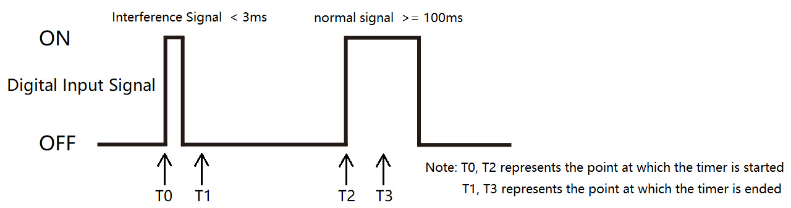

As shown in Figure 5-1: assuming the filtering time is set to 10ms, the time difference between T0 and T1, T2 and T3 is all 10ms (filtering timing time). At the time point T1, the digital input signal is OFF. This time, the input signal is judged to be OFF, so the interference signal will be filtered out. At time point T3, the digital input signal is in the state of ON, and this time the input signal is judged to be ON, so the normal input signal will be detected normally.

The detected filtering time can be set by pressing the button (Refer to steps 2 in 4.5.9) or by communication command (Please refer to the relevant communication protocol document for the register address). If the filtering time is set to 0, filtering is not enabled.

Note: ON represents the input digital signal is closed state; OFF represents the input digital signal is disconnected state.

**Chapter 6. Digital output (DO) interface**

The power meter can support 2 channels of digital output (DO1 and DO2). Digital output has two working modes: manual control and alarm control.

Manual control mode: Users can switch the digital output interface by pressing the button (Refer to steps 5 in 4.5.10) or use communication commands for remote control.

Alarm control mode: By associating the alarm monitoring object, the product can automatically switch the digital output interface according to the value of the monitored object (refer to the introduction of alarm function in Chapter 7).

The digital output interface has two output modes: level output mode and pulse output mode.

Level output mode: after the digital output is set to ON state, it will always remain ON state and will not switch to OFF state until it is set to OFF state.

Pulse output mode: After the digital output is set to ON state, the timing will start. When the timing time is equal to the width of DO pulse, the digital output will automatically switch back to OFF state.

The output mode and DO pulse width time of digital output can be set from the Settings menu (refer to the operation steps in 4.5.10) or by using the communication command.

Note: ON represents the relay is closed state; OFF represents the relay is disconnected state.

**Chapter 7. Alarm**

The power meter can support 2 channels of alarm functiont (AL1 and AL2), alarm action is related to the digital output interface, according to the real-time measurement data of the monitoring object automatically control the digital output interface to switch to the corresponding state (ON or OFF). The alarm function is to bind a monitoring object on the alarm channel and compare the measured data of the monitoring object with the alarm threshold value every second to determine whether the alarm threshold value is exceeded or trigger the alarm action.

**Note:** If the measurement wire type, CT, PT and other parameters of the power meter are modified, all alarm functions will be disabled to prevent unnecessary alarm events. It is necessary to confirm whether the alarm parameters are correct and then restart the alarm function.

7.1. Alarm parameter description

1. Alarm monitoring object: Alarm related measurement parameter. The power meter compares the data of this measurement parameter every second to determine whether the alarm threshold is exceeded, so as to decide whether to trigger the alarm. Alarm monitoring objects support 37 kinds of measurement parameters, the specific measurement parameters are shown in Table 7-1 below.

2. Alarm action delay time: When an alarm event occurs, the alarm action will be performed only after the delay time. If the delay time is set to 0, the alarm action will be executed immediately.

3. High-threshold alarm trigger value (HC): When the measured data of the monitored object is greater than the trigger value, high-threshold alarm event will be triggered.

4. High-threshold alarm release value (HO): When a high-threshold alarm event is triggered, the alarm state will exit only if the measured data of the monitored object is less than the release value.

5. Low threshold alarm release value (LO): When the low threshold alarm event is triggered, the alarm state will exit only if the measured data of the monitored object is greater than the release value.

6. Low threshold alarm trigger value (LC): When the measured data of the monitored object is less than the trigger value, low threshold alarm event will be triggered.

7. Alarm enabled: The function used to control the alarm is turned on or off. Only when the alarm enabling control value is set to the state of being turned on, can the power meter normally operate the alarm workflow.

Table 7-1: Alarm monitoring object

|  |  |  |  |  |  |
| --- | --- | --- | --- | --- | --- |
| **Number** | **Alarm parameter** | **Number** | **Alarm parameter** | **Number** | **Alarm parameter** |
| 0 | Phase 1 line to neutral volts. | 13 | Phase 1 active power. | 26 | Phase 2 power factor. |
| 1 | Phase 2 line to neutral volts. | 14 | Phase 2 active power. | 27 | Phase 3 power factor . |
| 2 | Phase 3 line to neutral volts. | 15 | Phase 3 active power. | 28 | Total system power factor. |
| 3 | Average line to neutral volts. | 16 | Total system active power. | 29 | Frequency of supply voltages. |
| 4 | Line 1 to Line 2 volts. | 17 | Phase 1 reactive power. | 30 | Line to neutral voltage of per phase |
| 5 | Line 2 to Line 3 volts. | 18 | Phase 2 reactive power. | 31 | Line to line voltage of per phase |
| 6 | Line 3 to Line 1 volts. | 19 | Phase 3 reactive power. | 32 | Current of per phase |
| 7 | Average line to line volts. | 20 | Total system reactive power. | 33 | Active power of per phase |
| 8 | Phase 1 current. | 21 | Phase 1 apparent power. | 34 | Reactive power of per phase |
| 9 | Phase 2 current. | 22 | Phase 2 apparent power. | 35 | Apparent power of per phase |
| 10 | Phase 3 current. | 23 | Phase 3 apparent power. | 36 | Power factor of per phase |
| 11 | Average line current. | 24 | Total system apparent power. |  | |
| 12 | Neutral current. | 25 | Phase 1 power factor. |  | |

**Note:** Per phase L-N voltage and L-L voltage, per phase current, per phase active/reactive/apparent power, per phase power factor belonging to the split phase parameters (containing the L1, L2, L3 parameters). When the monitoring object of the product binding is the split phase parameter, as long as any phase parameter exceeds the alarm threshold, the alarm event will be triggered; only when the parameters of all three phases are in the state of unalarm, the alarm state of the alarm channel will be lifted.

## 7.2. Alarm parameter setting process

Step1: Select the alarm channel.

Step2: Bind the alarm monitoring object.

Step3: Set the alarm action delay time.

Step4: Set high threshold alarm trigger value and high threshold alarm release value.

Step5: Set low threshold alarm release value and low threshold alarm trigger value.

Step6: Turn on the alarm function.

**Note:**

1, The alarm parameters can be set from the Settings menu (refer to the operation steps in 4.5.11) or by using the communication command.

2, When readjusting the alarm threshold value, please turn off the alarm function first to prevent the alarm event from being triggered by mistake during the numerical adjustment.

3, After each reset of the alarm monitoring object, the alarm function will be automatically turned off in order to prevent the wrong triggering of the alarm, and the setting of the alarm monitoring object is required. When the alarm monitoring object reset is complete, need to reopen the alarm function.

4, The setting process of alarm threshold shall ensure that: high threshold alarm trigger value > high threshold alarm relief value > low threshold alarm relief value > Low threshold alarm trigger value, otherwise an error will occur during the execution of the alarm function.

## 7.3. Rules for alarm monitoring

Figure 7-1: Diagram of alarm monitoring process

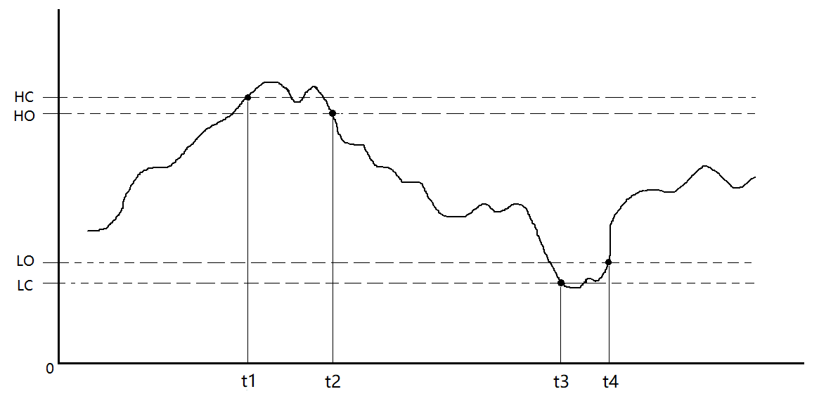

Note: HC represents High-threshold alarm trigger value.

HO represents High-threshold alarm release value.

LO represents Low threshold alarm release value.

LC represents Low threshold alarm trigger value.

As shown in Figure 5-1:

1. At time T1, when the power meter detects that the value of the monitored object is greater than the trigger value of the high-threshold alarm, the high-threshold alarm event of the power meter is triggered.

2. During the time period from T1 to T2, although the value of the monitoring object appears less than the high-threshold alarm trigger value, it is still greater than the high-threshold alarm release value, so the power meter is still in the high-threshold alarm state.

3. At time point T2, if the power meter detects that the value of the monitored object is less than the high-threshold alarm release value, then the power meter will exit the high-alarm state.

4. At time point T3, the power meter detects that the value of the monitored object is less than the low-threshold trigger alarm, and then the low-threshold alarm event of the power meter is triggered.

5. During the period of T3 ~ T4, although the value of the monitored object appears greater than the low threshold alarm trigger value, it is still smaller than the low threshold alarm release value, so the power meter is still in the state of low threshold alarm.

6. At the time point T4, when the power meter detects that the value of the monitored object is greater than the low-threshold alarm release value, the power meter will exit the low-alarm state.

## 7.4. Alarm action process

When the alarm event is triggered, first judge whether the "delay time of alarm action" is equal to 0. If it is equal to 0, immediately execute the following alarm action; if it is not equal to 0, start the delay first, and execute the following alarm action after the delay time reaches the set time.

Alarm action of the power meter:

1. The relay at the digital output interface of the corresponding channel will become ON state (AL1 corresponds to DO1, AL2 corresponds to DO2).

2. The icon will be flashing.

3. An SOE event is generated and recorded to storage.

## 7.5. View the alarm event record

Refer to the operation steps in 4.5.12, enter the display of SOE event, and the record information of the alarm event can be found by turning the page. After entering the query menu of the next level, the occurrence time, alarm type and object, trigger value of the alarm event and other information can be inquired, as shown in the figure 7-2 below. In addition, you can also use the communication command to read the specified register to obtain relevant information (please refer to the relevant communication protocol documentation for the register address).

Figure 7-2: Display diagram of record information query of alarm event

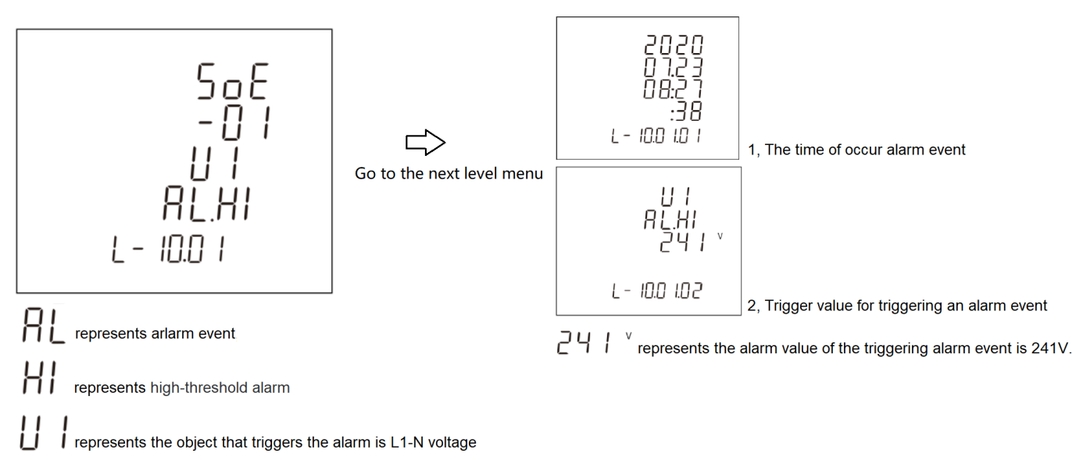

As shown in figure 7-2, the specific meaning of the display information of the alarm event is described.

**Chapter 8．Modbus register address table**

1. For the register address list of PAC5000, please refer to the “Nova PAC5000 Protocol [EN].docx” document.
2. For the register address list of PAC5010, please refer to the “Nova PAC5010 Protocol [EN].docx” document.
3. For the register address list of PAC5110, please refer to the “Nova PAC5110 Protocol [EN].docx” document.

## Appendix

## Appendix A – LCD character definition table

|  |  |  |  |  |  |  |  |  |  |
| --- | --- | --- | --- | --- | --- | --- | --- | --- | --- |
|  |  |  |  |  |  |  |  |  |  |
| **0** | **1** | **2** | **3** | **4** | **5** | **6** | **7** | **8** | **9** |
|  |  |  |  |  |  |  |  |  |  |
| **A** | **B** | **C** | **D** | **E** | **F** | **G** | **H** | **I** | **J** |
|  |  |  |  |  |  |  |  |  |  |
| **K** | **L** | **M** | **N** | **O** | **P** | **Q** | **R** | **S** | **T** |
|  |  |  |  |  |  |  | | | |
| **U** | **V** | **W** | **X** | **Y** | **Z** |

## Appendix B – Power meter functional comparison table

|  |  |  |  |  |
| --- | --- | --- | --- | --- |
| Features | Model | | | |
| PAC5000 | PAC5010 | PAC5100 | PAC5110 |
| Measurement Class | | | | |
| Voltage | ■ | ■ | ■ | ■ |
| Current | ■ | ■ | ■ | ■ |
| Active power | ■ | ■ | ■ | ■ |
| Reactive power | ■ | ■ | ■ | ■ |
| Apparent power | ■ | ■ | ■ | ■ |
| Power factor | ■ | ■ | ■ | ■ |
| Phase angle | ■ | ■ | ■ | ■ |
| Frequency | ■ | ■ | ■ | ■ |
| Active energy | ■ | ■ | ■ | ■ |
| Reactive energy | ■ | ■ | ■ | ■ |
| Apparent energy | ■ | ■ | ■ | ■ |
| Per phase energy | ■ | ■ | ■ | ■ |
| Mulit-tariff energy (T1 to T4) | － | ■ | － | ■ |
| Monthly energy consumption for the last 12 months | － | ■ | － | ■ |
| Daily energy consumption for the last 31 days | － | ■ | － | ■ |
| Demand Class | | | | |
| Demand of per phase and neutral current | ■ | ■ | ■ | ■ |
| Demand of total active power | ■ | ■ | ■ | ■ |
| Demand of total reactive power | ■ | ■ | ■ | ■ |
| Demand of total apparent power | ■ | ■ | ■ | ■ |
| The occur time of max. demand | － | ■ | － | ■ |
| Max./Min. Value Class | | | | |
| Voltage | ■ | ■ | ■ | ■ |
| Current | ■ | ■ | ■ | ■ |
| Active energy | ■ | ■ | ■ | ■ |
| Reactive energy | ■ | ■ | ■ | ■ |
| Apparent energy | ■ | ■ | ■ | ■ |
| Power factor | ■ | ■ | ■ | ■ |
| Voltage THD | ■ | ■ | ■ | ■ |
| Current THD | ■ | ■ | ■ | ■ |
| The occur time of max./min. value | － | ■ | － | ■ |
| Power Quality Class | | | | |
| THD of voltage/current | ■ | ■ | ■ | ■ |
| IHD of voltage/current | 31th | 63th | 63th | 63th |
| Nature of load | ■ | ■ | ■ | ■ |
| Voltage crest factor | － | ■ | ■ | ■ |
| Current K factor | － | ■ | ■ | ■ |
| Displacement power factor (DPF) | － | ■ | ■ | ■ |
| Voltage/current negative-sequence factor | － | ■ | ■ | ■ |
| Voltage/current zero-sequence factor | － | ■ | ■ | ■ |
| DI/DO Class | | | | |
| DI number | － | － | 4 | 4 |
| DO number | － | － | 2 | 2 |
| Alarm monitoring object | － | － | 37 | 37 |
| System Function Class | | | | |
| RTC | － | ■ | － | ■ |
| Mulit-tariff | － | ■ | － | ■ |
| Continuous running time of the power meter | ■ | ■ | ■ | ■ |

## Appendix C – Introduction to the main display screen

|  |  |
| --- | --- |
| 1. Display example of measurement data | |
|  | A display screen for three-phase L-N voltage.  Example:  L1-N voltage = 230.0V  L2-N voltage = 230.0V  L3-N voltage = 230.0V |
|  | A display screen for three-phase L-L voltage.  Example:  L1-2 voltage = 400.0V  L2-3 voltage = 400.0V  L3-1 voltage = 400.0V |
|  | A display screen for three-phase current and neutral current.  Example:  L1 current = 5.001A  L2 current = 5.002A  L3 current = 5.000A  Neutral current = 0.001A |
|  | A display screen for three-phase L-N voltage THD.  Example:  L1 voltage THD = 4.06%  L2 voltage THD = 3.98%  L3 voltage THD = 4.12% |
|  | A display screen for three-phase L-L voltage THD.  Example:  L1-2 voltage THD = 4.06%  L2-3 voltage THD = 3.98%  L3-1 voltage THD = 0.00% |
|  | A display screen for three-phase current THD.  Example:  L1 current THD = 4.06%  L2 current THD = 4.05%  L3 current THD = 4.04% |
|  | Voltage and current phase sequence display screen  **Note:**  1.  represents the phase sequence of the voltage. 123 represents forward sequence, 321 represents reverse sequence.  2.  represents the phase sequence of the current. 123 represents forward sequence, 321 represents reverse sequence. |
|  | Total power factor and frequency display screen  Example:  Total power factor = 0.503  Frequency = 50.02Hz |
|  | Three - phase power factor display screen  Example:  L1 power factor = 0.506  L2 power factor = 0.502  L3 power factor = 0.501 |
|  | Max.demand of three-phase and neutral current display screen  Example:  Max.Demand of L1 current = 5.002A  Max.Demand of L2 current = 5.003A  Max.Demand of L3 current = 5.000A  Max.Demand of neutral current = 0.002A |
|  | Max.demand of total active/reactive/apparent power display screen  Example:  Max.Demand of total active power = 1.560 kW  Max.Demand of total reactive power = 2.867 kvar  Max.Demand of total apparent power = 3.197 kVA |
|  | Per phase active power display screen  Example:  L1 active power = 0.551 kW  L2 active power = 0.548 kW  L3 active power = 0.550 kW |
|  | Per phase reactive power display screen  Example:  L1 reactive power = 0.952 kvar  L2 reactive power = 0.944 kvar  L3 reactive power = 0.948 kvar |
|  | Per phase apparent power display screen  Example:  L1 apparent power = 1.100 kVA  L2 apparent power = 1.096 kVA  L3 apparent power = 1.082 kVA |
|  | Total active/reactive/apparent power display screen  Example:  Total active power = 1.649 kW  Total reactive power = 2.844 kvar  Total apparent power = 3.278 kVA |
| 1. Display example of energy data | |
|  | Total active energy |
|  | Import active energy |
|  | Export active energy |
|  | Total reactive energy |
|  | Import reactive energy |
|  | Export reactive energy |
|  | Tariff 1 active energy |
|  | Tariff 2 active energy |
|  | Tariff 3 active energy  Note:  represents that the current rate number is a running tariff segment, i.e., the tariff 3 (T3) is valid. |
|  | Tariff 4 active energy |
| 1. Display example of real-time clock data of the system (RTC) | |
|  | Example of displaying the current date of the system real-time clock. |
|  | Example of displaying the current time of the system real-time clock.  Note: The figure on the left represents the tariff segment to which the current time belongs tariff 3 (T3). |

## Appendix D – Introduction to auxiliary information display screen

|  |  |
| --- | --- |
| **1.** **Options for auxiliary display screen** | |
|  | Per phase measurement class display option |
|  | Max./Min.value class display option |
|  | Sub-harmonic component of voltage display option |
|  | Sub-harmonic component of current display option |
|  | Extended information class display option |
| **2. Display example of auxiliary display screen** | |
| **2.1. Example of display screen for per phase measurement class** | |
|  | L1 active power, L1-N voltage, L1 current and L1 active energy display screen |
|  | L2 active power, L2-N voltage, L2 current and L2 active energy display screen |
|  | L3 active power, L3-N voltage, L3 current and L3 active energy display screen |
|  | L1 active power, L1-N voltage, L1 current and L1 reactive energy display screen |
|  | L2 active power, L2-N voltage, L2 current and L2 reactive energy display screen |
|  | L3 active power, L3-N voltage, L3 current and L3 reactive energy display screen |
| **2.2. Example of display screen for Max./Min. value class** | |
|  | Max.value of per phase L-N voltage |
|  | Max.value of per phase L-L voltage |
|  | Max.value of per phase and neutral current |
|  | Max.value of per phase active power |
|  | Max.value of per phase reactive power |
|  | Max.value of per phase apparent power |
|  | Max.value of per total active/reactive/apparent power |
|  | Min.value of per phase L-N voltage |
|  | Min.value of per phase L-L voltage |
|  | Min.value of per phase and neutral current |
|  | Min.value of per phase active power |
|  | Min.value of per phase reactive power |
|  | Min.value of per phase apparent power |
|  | Min.value of per total active/reactive/apparent power |
| **2.3. Example of display screen for individual harmonic distortion of voltage** | |
|  | Individual harmonic distortion of voltage  Note:  represents the current displayed voltage harmonics component is the second harmonics. |
| **2.4. Example of display screen for** **individual harmonic distortion of current** | |
|  | Individual harmonic distortion of current  Note:  represents the current displayed current harmonics component is the second harmonics. |
| **2.5. Example of display screen for extended information** | |
|  | Modbus address |
|  | Baud rate |
|  | Parity bit |
|  | Ratio of current transformer (CT) |
|  | Ratio of voltage transformer (PT) |
|  | Continuous running time of the power meter  **Note:** As shown in the left figure, the figures in the first row represent the days of continuous operation of the power meter, the figures in the third row represent the hours and minutes of continuous operation of the power meter, and the example the power meter in the left figure has been continuously running for 3 days, 16 hours and 20 minutes. |
|  | Software version number |
|  | The screen lights all LCD segments and can be used as a display LCD check. |